## 

**Wordshark & Numbershark v5 Windows Networks**

**Installation,** Updating **&** Migration **Instructions & Links to MSIs**

Revision Date: 2nd June 2021

*RM CC4 networks need* [*different MSIs and instructions.*](http://www.wordsharksupport.co.uk/customer-uploads/cc4/CC4.pdf) *This product is not suitable for native use on Apple Mac networks, but it may be installed onto a Windows Server and from there be*  virtualised *out to Mac clients & other devices. For Mac, Chromebook & iPads, consider our “*[*Wordshark OnLine*](https://www.wordshark.co.uk/wordshark/schools/)*” product (no Numbershark on-line equivalent yet available)*

**You need to skim read this page, then read pages 3 - 13 of these instructions.** This document is designed for on-screen reading & searching, hyperlinking to additional information from the Contents page, page 2.

The install process is identical for both Wordshark v5 and Numbershark v5: ***Do not use if installing our v4 products*.** *If you have previously installed or worked with v3 or v4 Wordshark or Numbershark versions,* ***note*** *that installation methods changed significantly after v4.08 and you* ***will*** *need to read these instructions.*

* **If migrating/updating/rebuilding your server**, please read **Appendix I** first.
* If you are **installing on a server farm hosting multiple instances** of Wordshark and/or Numbershark networks, read Appendix K before proceeding as the install process is significantly different.
* **If you are installing ONLY Wordshark or ONLY Numbershark,** just follow these instructions. If working on Numbershark, substitute “numbershark” in place of “wordshark” throughout.
* **If you are installing both Wordshark and Numbershark together**, use these instructions but preferably start with **Numbershark** as this hosts the diagnostics for both programs. Complete stages 1-4 for Numbershark. Then, install Wordshark: At Stage 1 step 3, use the same “White Space Software” folder. At step 8, choose to install into the folder SENIOR to the “White Space Ltd” folder: The installer will create the Wordshark program files within the “White Space Ltd” folder, alongside your Numbershark program files. At “Stage 2” you will NOT need to install a 2nd instance of the “Service and Manager”, as these serve both programs. Close these and reopen, and the Numbershark line should be visible in the “White Space Manager” awaiting activation.
* **If Wordshark v4.10 or v5 has already been installed for some time, and you are now installing Numbershark** (or vice versa), again follow the instructions plus these three points:
  + At Stage 1 step 3, use the same “*White Space Software*” folder. At step 8, choose to install into the folder SENIOR to the “*White Space Ltd*” folder: The installer will create the Numbershark *program files* within the “*White Space Ltd*” folder, alongside your Wordshark *program files*.
  + At Stage 2, go to the server “installed programs” and check the version of “White Space Network Manager” is v1.0.8.0 (for S2012 and older servers running .Net 3.5) or v2.0.0.0 (for S2019 and newer servers running .Net 4.7.2) If an earlier version is installed, we recommend you update, by running the “setup network management.exe” (downloaded into your Numbershark source files folder at “Stage 1”).
  + **Numbershark** hosts the diagnostics for both programs. Notice that our diagnostics files location will switch from *wordshark-shared/diagnostics* to *numbershark-shared/diagnostics* and will start to include both programs.

***If you are reading this on a paper printout****, these instructions and your MSIs are likely to be out of date. Visit* [*http://www.wordshark.co.uk/Downloads/ws5n.aspx*](http://www.wordshark.co.uk/Downloads/ws5n.aspx) *to upload the latest instructions and MSIs*

*Contents*

Contents

Essential Information & Overview 3

Stage 1: Download MSIs, create the user data folder, install program files to server 4

Stage 2: Setting up the manager and service 6

Stage 3: Deployment to Client Machines 10

Stage 4: Important post-install tasks for the Installing Technician 10

Stage 4a: Initial setup 10

Stage 4b: Testing 12

Stage 4c: Documentation & Backup 13

Stage 4d: Set up Users 14

Stage 4e: Handover to Education Staff 14

CONTACTS: How to Obtain Support 16

Appendix A: Trouble-shooting (including common errors and error codes) 17

Appendix B: Licence & related FAQs & Server Migrations/Rebuilds 28

Appendix C: Special Situations inc. Load Balancing, Linux, VPN, Virtualising to Devices 29

Appendix D: Adding Additional Concurrent User Licences 33

Appendix E: Peer to Peer Windows Networks 33

Appendix F: Creating and Deploying Shortcuts 33

Appendix G: System Requirements 34

Appendix H: Sharing and hiding Folders & Setting Permissions 36

Appendix I: Upgrading / Updating / Migrating or Rebuilding Servers 37

Appendix J: Installing the Program onto Client Machines 47

Appendix K: Server farms hosting multiple schools’ Wordshark/Numbershark networks: “New Product Instances (NPI)” 51

Appendix L: Updating the Service and Manager 55

Appendix M: Template Email/letter for Installing Technician 56

Appendix N: SCCM Deployment 57

Appendix O: GDPR Compliance for Version 5 Wordshark and Numbershark 59

Appendix P: Reducing Server Disk Space Requirements 60

Appendix Q: How to check that .Net is present 61

# Essential Information & Overview

These instructions apply to standard Windows networks. Networks vary in configuration, and appendices cover additional configurations and issues. **Detailed system requirements** are at Appendix G. If you experience any difficulties, most issues including error messages and codes encountered are covered in Appendix A: Trouble- shooting. You can also contact support, but please provide supporting information to help us.

**If you are NOT using Active Directory**: You will need to check regularly that the server and all clients are on the same time and time-zone, as our programs can cope with a variation of <10 minutes only.

**If upgrading from an earlier instance of either program, or reinstalling as part of a server migration, read** **APPENDIX I: Upgrading Instructions** **before proceeding, to avoid possible data loss.**

**The purchase price covers the cost of the software, with the requirement that the school’s own IT support staff then downloads, installs to the server and deploys to client machines.**

**Should the installing tech experience any issues, our own support team can provide** **reasonable****support** **to that technician. These instructions also cover what to do in the event of a** **server migration** **and** **troubleshooting** **install and post install issues**

As a guide, we find around 95% of network purchases need no direct input from our technical support team.

Feedback indicates that most competent school techs complete stages 1-3* in under 90 minutes if new to the programs, and under one hour for the 2nd program. * not including the time the server takes to carry out automatic silent deployment /deployment GPO, which may be best scheduled overnight

The install has **four** stages:

* **Overview of Stage 1:** Create a folder & download self-extracting MSIs from the links provided. Run the MSI that creates a data folder *wordshark-shared* which holds user and licence data, and a further MSI that installs the *program files* onto your server.
* **Overview of Stage 2:** Install a *White Space Network Manager* programwhich works with a linked *service* to manage licence activation and diagnostics, then activate the licence.
* **Overview of Stage 3**: Deploy the program to wireless & frequently used client machines. Optionally, create desktop or start menu shortcut icons for remaining client machines.
* **Overview of Stage 4**: Set up initial user accounts, test, document, and brief end users

**Licence:**

Your whole-site Network Licence is for “Concurrent Users” NOT “number of clients”. You are permitted to deploy the program to **every** client computer on your network, and it may be used by **all** staff and students. The licence will indicate the maximum number of “Concurrent Users” allowed. Our program activation system ensures that you do not require separate licence compliance software. Licence FAQs are included at Appendix B.

GDPR Compliance

***We are grateful to*** [*http://www.businessdictionary.com/*](http://www.businessdictionary.com/) ***for the following definition:***

***Computer Expert***:

Someone who has not read the instructions, but who will nevertheless feel qualified to install a program and, when it does not function correctly, pronounce it incompatible with the operating system. *(Priscilla Mann)*

***Too many of our network support cases involve computer experts unaware of this definition, having not read this page…. Thank-you for reading this far (don’t give up yet!). We will be happy to help you if any of these instructions do not make sense to you: Please*** *contact us* ***if the “****troubleshooting****” section does not help resolve any issues you encounter.***

Navigate to: Contents Instructions Stage 1 Stage 2 Stage 3 Stage 4 Trouble-shooting Contact

# Stage 1: Download MSIs, create the user data folder, install program files to server

If you are installing multiple instances of the same White Space network product (e.g. on a county or region network), and already running at least one instance of the product you are currently installing, do **not** run the server MSIs to install licences for additional schools. **Instead**, see Appendix K, and use the “New Product Instance” (NPI) facility provided in the White Space Network Manager.

**In this stage, you will create a folder and then follow a link to download the self-extracting MSIs .exe file. You will run the S-Server MSI to create a data folder *wordshark-shared* which holds student work, records, diagnostics and data required for the program to run. This is located on your server in a network-accessible shared folder. This MSI also installs the *program files* onto your server, into the folders *wordshark-programs* and *wordshark-public.***

1. Log on as a domain (network) administrator to the **server that will host the program & user data.** Wordshark and Numbershark are huge applications, with potentially whole-school use. Check you have sufficient server disk space. Allow 8Gb for the two program files, source files & growth of user data, but note that Appendix P gives advice on reducing server disk space requirements significantly.
2. Multiple schools (e.g. for “Multi-academy trusts” or districts with central IT control)’ *wordshark-shared* folders (one per school) can all be located on the same server. If this is needed for this install, read Appendix K before progressing and if in any doubt contact Support.
3. On your server hosting our program *service,* check the version of .Net Framework installed*.* Check that .NET has ALSO been enabled. *Supporting notes*
4. **Choose your .Net Framework:** The server hosting the *service* must have .NET Framework installed *and* enabled. You have a choice:
   1. **For modern servers, particularly S2012 and later,** ensure you have .NET Framework 4.7.2 or later (if you may need to update the installed 4.7.0) At Stage 2 you will use our Network Management v2.0.0.0 **For older servers** still using .NET 3.5, [contact Support](mailto:support@wordshark.co.uk?subject=Installing%20and%20Need%20%20S&M%201.0.8.0:%20Am%20using%20.Net%203.5) and ask for our older Network Management v1.0.8.0.
   2. Note we have added .Net source folders within the self-extracting zipfiles should you need these
   3. *wordshark-shared* may be situated on a different server to the *service* and *manager* *but read these notes if you need to do this*
   4. The *service* and *manager* may be on different servers but need to communicate with each other internally via port 9001 (default): A different port may be selected during install. To reduce potential issues (e.g. internal firewalls) **we advise you co-locate onto a single server the White Space Network Manager+Service and the data folder *wordshark-shared.***
5. Create a folder, e.g. “*White Space Software*” within an existing “share” on your server: If you have an application data share or location where you install your network applications’ data this is a good place for this folder, which acts as the senior folder for both of our programs. **Check** that you have “Full Access” to this folder. *There is no need for drive mappings: Mapped drives will not work.* Do NOT attempt to install onto the root of the server C: drive. This is normally barred as a group policy.
6. Inside the *White Space Software* folder, create a folder (e.g. “S*ource files*” ). Create subfolders for “Wordshark source files” and/or “Numbershark source files” (depending on which you have purchased). Download the self- extracting MSI file(s), directly to the appropriate sub-folder from the following links:

|  |  |
| --- | --- |
| [**Wordshark Network MSIs**](https://secure.wordshark.net/Downloads/resources/Downloads/WCNA/WordsharkNetworkFiles.exe) | **[Numbershark Network MSIs](https://secure.wordshark.net/Downloads/resources/Downloads/NCNA/NumbersharkNetworkFiles.exe)** |

1. *If you have already downloaded to a different location, we recommend you move your downloaded MSI files to the server which will host your program user data folder. Remoting to a server whilst retaining the downloaded MSIs on a client machine can create incorrect registry entries and is a common reason for failure, as it is easy to accidentally install elements onto the local machine*.
2. Unzip the downloaded self-extracting MSI files into *wordshark source files* folder*.*
3. Look in the *wordshark source files* folder. Find and run the “*Wordshark 5 Network S-Server.msi*”. Browse & install to the *“White Space Software”* folder. The installer will install a subdirectory *White Space Ltd /Wordshark 5 Network* containing folders *wordshark-programs* and *wordshark-public*

* The .msi extension might not show on all systems. The .msi name will include the exact release, e.g. Wordshark 5 Network S-Server 5 001 01.msi. This may be helpful if you download subsequently and want to check you are using the latest release. This MUST be run on the server on which you intend to run the SERVICE. For this reason, it is easier to install the *service*, *manager* and data folder on the same server. ***What to do if you need to install to different servers***
  1. You may be prompted with a security check before the MSI launches. Click “OK” or “Run”, then follow the on-screen instructions and accept the Licence Agreement.
  2. **The installer offers to import data from a previous version: If applicable, browse to the old wordshark- shared folder, and check that this is still set to allow full access: The installer detects and imports the required files. (****See Appendix I****)**

1. **The MSI will create the user data folder:** The installer will ask where to create the Wordshark program files and the user data folder (*wordshark-shared*). Note that *wordshark-shared* is **case sensitive.**
   1. Folder paths must be seen by client machines so need a UNC format network share path.
   2. Choose the *White Space Software* folder:
   3. The “*Wordshark 5 Network S-Server.msi*” will create the data folder “*wordshark-shared*” automatically.
   4. If you need to put “*wordshark-shared*” into a folder other than within *White Space Ltd* (e.g. a multi- school install)*,* you will need to create this parent folder manually first, before specifying the location. Browse to the ***parent*** folder in which you want the *wordshark-shared* folder to be created; e.g. to create *\\SchoolServer1\ White Space Software \ White Space Ltd\wordshark-shared*select the *“\\SchoolServer1\ White Space Software \ White Space Ltd”* folder.
2. **Set the Sharing and Security** on the case-sensitive user data folder *wordshark-shared (****required*** *even though you are installing into a folder which is already a “network share”)* The existing share may be “hidden” with a $ but ensure that you use ADVANCED SHARING for *wordshark-shared.* Refer to Appendix H. if unsure about sharing or hiding folders. To ensure a successful deployment use **UNC paths throughout**, i.e. you should end with a folder shared n the format *“servername/wordshark-shared”.*

**a. Security tab**: A minimum of **read/write/modify/delete** file permissions for **all users** is required for the case-sensitive *wordshark-shared* folder. (“Everyone” “Full Control” ensures success – otherwise read Appendix H)

b. **Sharing tab**: You will need “Advanced Sharing” turned on. Select “Advanced Sharing” for

“**Everyone**”. You will need to select the “Advanced Tab” /”Permissions” / “Full control for “Everyone” (or read Appendix H). Note: Setting lower permissions can lead to challenges later, including “silent deployment to client machines, or latter addition of more user groups.”. If you choose instead to set specific share/security permissions for multiple user groups, the Local System Account will need read, write, modify & delete permissions to the *wordshark-shared* shared folder.

c. Left-click on the (empty) folder *White Space Ltd/ wordshark-shared*. Right click on “Properties”, and the “Sharing” tab. Note that the “Network path” should now show a short UNC path, e.g. *server1\wordshark-shared* Having shared in this way, you will find that the *wordshark-shared* will have a shared short UNC path with no visible $ even if physically in a $ hidden area. **Note and copy the short share name.**

1. **Modify the Registry**: Open the Registry to HKEY Local machine/Software/Wow6432 Node/White Space/Networks/Wordshark5. Find the “Share path” entry and right click to “Modify”. Replace the long address with the short share name you have just copied e.g. replace D:\Data\Apps$\White Space Ltd\Wordshark5\wordshark-shared with the UNC path \\server\wordshark-shared

Navigate to: Contents Instructions Stage 1 Stage 2 Stage 3 Stage 4 Trouble-shooting Contact

# Stage 2: Setting up the manager and service

**In Stage 2, you will install a *White Space Network Manager* program** and its linked *service* which manages licence activation and diagnostics. You will use this to activate the licence.

**Important points to note before starting Stage 2:**

* **Recap: Choose your .Net Framework:** The server hosting the *service* must have .NET Framework installed and enabled. You have a choice (above, Stage 1) of using .Net 3.5 and our Network Management 1.0.8.0 or .Net 4.7.2 and our v2 Network Management. Both function in a similar way.
  + **For older servers**, use Network Management v1.0.8.0 and ensure you have .NET 3.5 enabled. (later releases of .NET do not include the required coding, but may run alongside 3.5)
  + **For newer servers, particularly S2019,** use the Network Management v2.0.0.0.exe and ensure you have .NET Framework 4.7.2+
  + Note we have added .Net source folders within the self-extracting zipfiles should you need these
  + The *manager* requires elevated privileges to run, as it writes to the registry.
  + For Wordshark to run correctly the *service* (listed in “Services” as “White Space Network Service”) **must** be running, as it handles licencing, diagnostics and other working elements. The “Manager” can be closed when activation is completed, and reopened if you need to deactivate (for server rebuild or migration) or are given a licence code to activate additional concurrent users.
  + White Space Ltd network products (Wordshark & Numbershark) versions 4.10 and 5 are managed by a single instance of the *service* and *manager*.
  + *wordshark-shared* may be situated on a different server to the *service* and *manager* *but read these notes if you need to do this*
  + The *service* and *manager* may be on different servers, but need to communicate with each other internally via port 9001 (default): A different port may be selected during install. To reduce potential issues (e.g. internal firewalls) we advise you co-locate the *service, manager* and *wordshark-shared.*
  + Multiple schools’ *wordshark-shared* folders can all be located on the same server. Appendix K
  + *UNC paths are required throughout. Drive mappings/mapped drives are not needed and do not work.*

1. 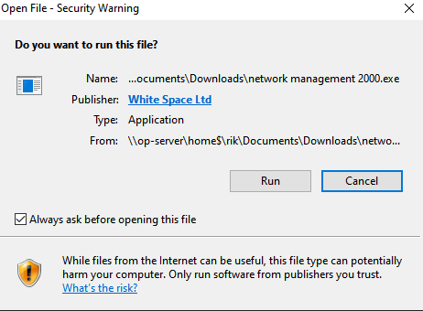Check (“Programs and features”) whether the server already has v1.0.8.0 or v2.0.0.0 installed (e.g. for the “sister” program Wordshark / Numbershark),in which case skip to activation
2. If you find an earlier version is installed, we recommend you update, by running the “setup network management.exe” (downloaded into your [Number][word]shark source files folder(s) at “Stage 1”). You may also update this component at any time post-install. There is no need to uninstall the earlier version first: The later release will over-write/update files.
3. **Install the *manager* and *service.*** To install, find “*setup network management.exe*” (for .Net 3.5) or “*setup network management2000.exe*” (for .Net 4.7.2). These should already be downloaded into your *wordshark source files* folder. Double-click to run the zip self-extraction routine. You may see warnings similar to these screenshots.
4. 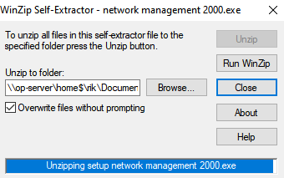By default, the *manager* and *service* are installed to the “*Program Files*” folder on the server. If you wish to install to an alternative location click the “Change” and select a new location. NOTE: Both the *manager* and the *service* **must** be installed, we advise onto the server hosting *wordshark-shared*. If your policies require the *service* & *manager* to be installed onto a different server, see “Special Situations”, Appendix C.
   1. You will be asked whether you need to “Install this application for all users / Only for me”. Normally, “All users” is appropriate.
   2. By default, the install is to the server c:\Program files (x86).
   3. **You will need to know whether your server “connects directly to the internet” or “connects via a proxy”** If the latter, enter the details when requested. This usually is in a format such as 172.18.2.35:8080 and in some cases may also require a proxy authentication username/password.

Note: If you enter a username and password, check whether the password is set to expire. The *service* will stop functioning if the password expires, and our programs will then malfunction. To avoid this, if your network security policy requires expiry, note to change the *service* Log On Credentials to the new password at the appropriate time (To do so, open the *service* from within Task Manager / Open Services / Right-click the White Space Network Service / Properties / Log On, enter the new password)

* 1. The accounts the *manager* and *service* run under need appropriate elevated permissions to start services and write to registry. Normally, the default “Local System Account” will work. However, if you then find that the *service* and *manager* fail to start, uninstall and reinstall entering a username and password with the required level of permissions. You may wish to set up an account specifically to run the service with only the minimum required privileges and excluded from any password expiration group policies.
  2. Mid-install you will be requested to enter the Log-On details for the *service*. On this screen, enter an account that has permissions to start the *service*, write to *wordshark-shared* and to the *Registry.* In almost all cases “Local System” usually works. Registry entries should appear in one of these locations:
     1. **64 bit servers:** HKEY_LOCAL_MACHINE\SOFTWARE\Wow6432Node\White Space Ltd
     2. **32 bit servers:** HKEY_LOCAL_MACHINE\SOFTWARE\White Space Ltd
  3. To start the *service* at any time, this is most easily started from Task Manager / Services / right –click on “White Space Network Service”. The *Manager* will not open unless the service is running. The icon for the *Manager* looks like this:

To open the *manager,* it is usually most convenient to go to the hidden icons tray in the task bar, right-click on the *manager* icon and click “SHOW”. If the *manager* icon is not showing in the hidden icons tray you will need to open the *White Space Network manager* program via the start menu.

1. Subsequent installs of other White Space products v4.10 or later, will use the same *manager* and *service.*

It is worth updating to the latest *manager* and *service* if installing at a later date. (Appendix L)

1. The installer will by default use network port 9001 for the service to communicate internally with the manager. If this port is already in use or your network infrastructure requires you to use another port, specify this on the Network Port page of the installer. If you are unsure which port to use click “Next” to accept port 9001. You may change this port or proxy details subsequently via the “Service Details” and “Proxy” tabs of the *manager*. If either tab is absent, update your *manager* to the latest version (Appendix L)
2. You may be prompted with a security check before the file launches. Click “OK” or “Run”. The installer will install the *manager* and *service* and add various entries to *wordshark-shared.* This may take several minutes.

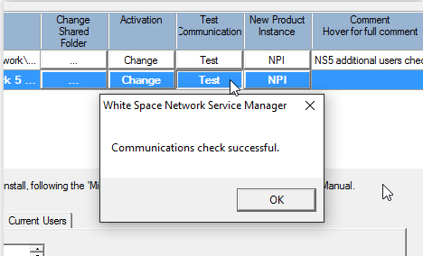

1. Once the *service* is installed you need to **activate your licence** before you are able to run the program.

Log on to the computer hosting the *manager* (usually the server) as a domain (network) administrator. Note the “Test” button: This will check whether our Service is able to communicate with the internet, without which you will need to adjust your proxy settings or else “proceed with off-line activation”:

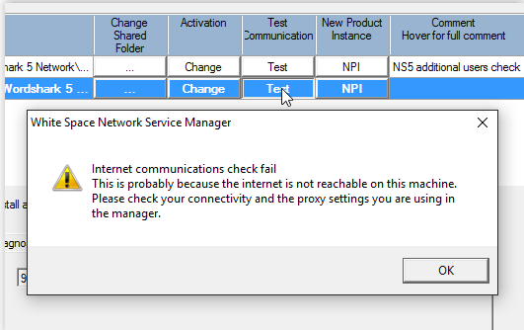

If there is no internet access, then the following message is given (Screenshot) Troubleshooting (Appendix A) gives further information about proxy settings and other manager settings.

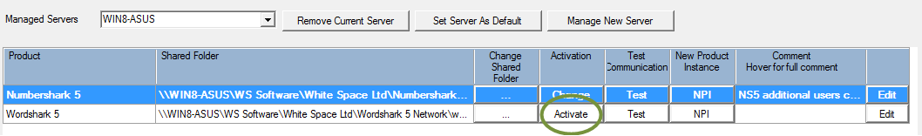Launch the “*White Space Network Manager*” from the start menu.

* 1. The *manager* will list the White Space network product(s) and each associated shared folder on the server*.*
  2. Click the product you wish to licence & click “Activate”.
  3. Follow the on-screen instructions to activate the software. The *manager* requires access to the internet for fast and automatic activation and deactivation. If internet access from this machine is not available, off-line activation and deactivation is offered as an option, though this is slower and less convenient.
  4. Note the “Diagnostics” tab in the lower portion of the *manager.* This is replicated (more usefully) within the *wordshark-shared\Diagnostics* folder.
  5. **Note the “Log Files” tab** in the lower portion of the *manager*: We suggest you control the growth of log files, either by size or date (see screenshot): The *White Space Network Service*, as well as handing out concurrent user tokens, also writes program diagnostics to the daily log files in the *wordshark-shared\Diagnostics* folder. If the program is working normally, anticipate around 58Kb per day for one program, and around 108Kb per day a little more if users are logged as signing on / off. 6 months of logs for the two programs is usually around 20Mb, and we suggest this as a sensible limit..

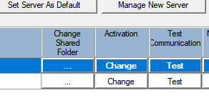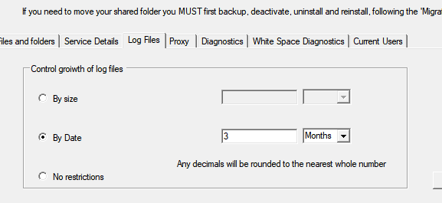

* 1. Note the “Current Users” tab – here you can close down a program left open by a user(whether or not they are still using it).
  2. Please note the contents of this white box: The “Change ” button for the relevant licence starts the deactivation process (screenshot)
* Each licence activates to a single specific instance of the program [word][number]shark-shared data folder.
* If you wish to **move the folder, rename or rebuild the host server, or migrate to a new server, you MUST first deactivate the licence: See** [**Appendix I**](#Appendix I:   Upgrading / Updating  / Migrating or Rebuilding Servers)
* **Failure to deactivate may result in loss of the licence or a charge for a replacement licence.** ***What to do if you have omitted this step***
* You may reactivate your licence to a new location up to five years from initial purchase.

Navigate to: Contents Instructions Stage 1 Stage 2 Stage 3 Stage 4 Trouble-shooting Contact

# Stage 3: Deployment to Client Machines

**In this stage, you will [A** below**] deploy the program to wireless & frequently used client machines**

Optionally, you may **[B** below**]** also create different desktop or start menu shortcut icons for client machines that are likely to only rarely use the program.

*A reminder – your licence allows deployment to an* ***unlimited*** *number of client Windows computers. You may also “virtualise” out to other devices via Citrix/RDP or similar, if your server is sufficiently powerful.*

***[A] For Wireless and frequently used client machines:***

***For fastest loading and minimal network traffic*** We recommend you deploy the full program to the client hard disks for local “Client-based” loading. This is *essential* for wireless clients, and *highly recommended* for client machines that will run the software frequently. Many organisations will simply deploy to ALL client machines, including those that use the program less frequently. For each option below, the client machines access the user data folder located on the server.

Manual, semi-automatic, silent and automated deployment option include:

* using your own in-house method/GPOs,
* via a manual install,
* via a fully automated silent install using our own Config file,
* via a command line

Appendix J provides details for most of these deployment options.

***[B] Alternative for all other wired client computers that use the program infrequently OR have minimal local spare disk space***

A desktop icon allowing the program to be run in “Server-based” mode, i.e. directly from the instance of the program on the server usually allows for faster deployment & updating, though at a cost of greatly increased network traffic and slower loading time for users. Placing an icon on the “Desktop of all users” (or appropriate groups) is normally the most convenient way to deploy the shortcut:

* The icon “Target” is the executable *Wordshark5nrun.exe* (within *wordshark-programs* on the server). The program WILL NOT launch correctly if run directly from *Wordshark5nrun.exe.*
* The icon’s “properties” / “Start-in” path MUST be the UNC path to the server *wordshark-shared* (as shown in the *manager* at stage 2). This is case sensitive. If incorrect, “Error Code 9” may be experienced on running.
* If your network policies prevent the desktop shortcut from being created, this can be created manually using the instructions in Appendix F
* If staff report “slow loading” from machines installed in this way, review to see whether these machines are used often enough to warrant deploying the full program to the client hard disks, i.e. “Client based”

Navigate to: Contents Instructions Stage 1 Stage 2 Stage 3 Stage 4 Trouble-shooting Contact

# Stage 4: Important post-install tasks for the Installing Technician

**In Stage 4, you will set up initial user accounts, test, document, and brief end users**

## Stage 4a: Initial setup

1. Log onto a client machine as a restricted (student) user: This will check your permissions & security settings for students are correct. Click on the desktop icon (or program group entry) to launch the program. IF the program opens to the first splash screen but fails to complete loading, it is failing at the point where it checks (by saying "Hello") that the sound is working. Check that speakers or headphones are plugged in and functioning, and check the soundcard driver.
2. At the initial sign-on screen, type your name or job title (we suggest the latter, e.g. “Network Admin” or “Technician”) in the box provided. Wordshark users each need a unique user ID, which may be their unique network login name, if recognisable. Any combinations of up to 30 letters, numbers and spaces are allowed. The following characters are NOT allowed: / ? * : | < > \ "

3*.* On first run you will be asked if you wish to become the program administrator. **Say yes** (you will add one or more school staff on as administrators below, at the next step). You will be asked to set a password and a password hint. Note your username/password in your installation documentation. If other users subsequently lose their own passwords for our programs **you** can sign on and change their password via the Admin / Add and Manage Students and Staff, then select the Administrator or Teacher and click the “Change” button.

1. Read the WARNING NOTE then go to Admin / Add and manage students & staff. In the left hand column, click on the “Administrator” icon and set up a member of staff as a further administrator. They can in turn add further program administrators and teachers.

WARNING NOTE

Note that any **Wordshark administrator** can subsequently reset passwords/user names for other administrators, teachers and students**. Administrators can also remote directly into the server program data folder wordshark-shared (and from there potentially elsewhere) via Admin/Advanced/Show wordshark-shared.**

For security, we advise that education staff users are registered as **Wordshark teachers (green icon for safety).** ONLY create **“Wordshark Administrator” (red for danger icon)** usernames for trusted member(s) of staff for whom direct access to servers is appropriate. If this person is, for example, the IT Manager but is also an IT teacher, it is fine for them to have a Wordshark Administrator account as “IT Manager(Admin)” to use behind closed doors ***and*** a 2nd username as a Wordshark Teacher account “IT Teacher” to use within the classroom

1. 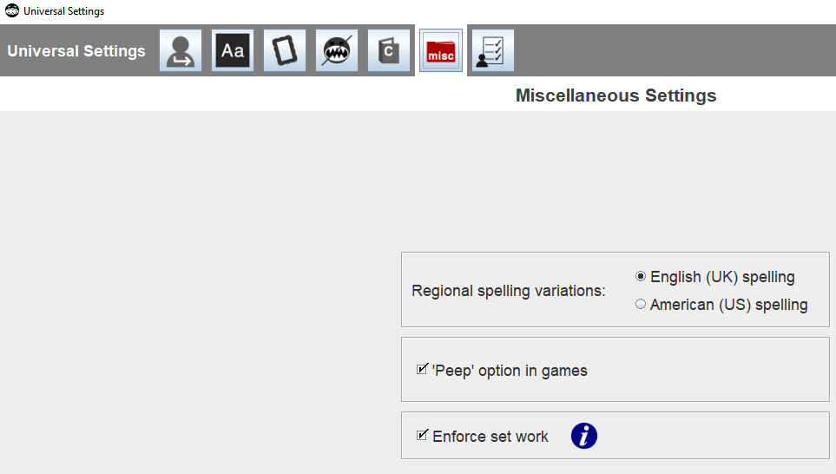**A) As you create the staff user’s program Wordshark Administrator name and password, we suggest you use the email template at** **Appendix M** **to pass this and other information on to your end user.**

**B) Within Admin/Universal, click on “Misc” and check that the appropriate spelling (UK or US) is chosen, then tick the box for “Enforce Set Work”: *If this box is not ticked*, then students have free choice for all games and all lists regardless of ability, and can also create their own word lists.**

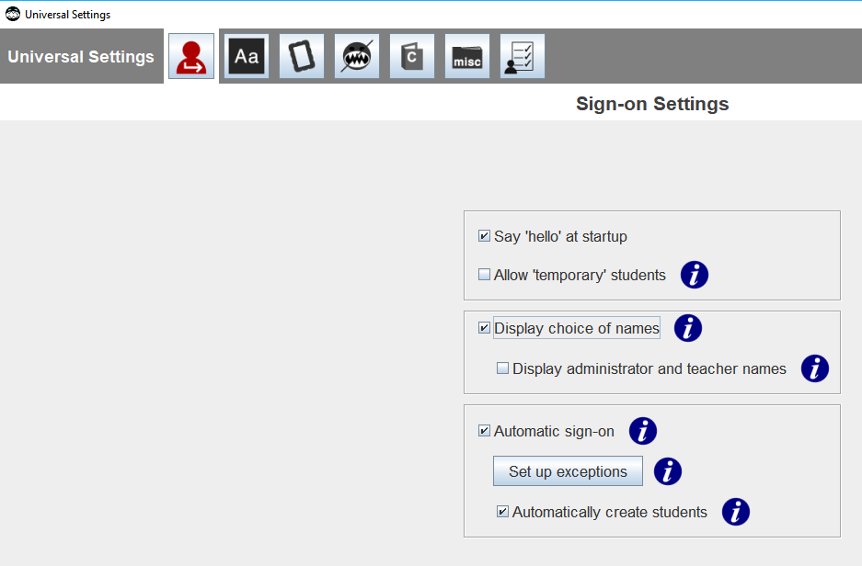

**C) If student users sign on with unique but recognisable Active Directory UserNames** you may save end user staff many hours of work: Go to Admin / Universal Options. Click on the first icon. We advise you UNTICK “Allow “temporary” students: This is useful for open days, but allows a student to sign on as an additional user with any name – obscene, naughty or otherwise! TICK the boxes for “Automatic sign-on” and “Automatically create students. If some (e.g. younger) classes sign on with a group username such as “Pupil”, then add this in the “Set up exceptions” option.

1. Close, log off and log back onto a client machine as a restricted (teacher) user: This will check your permissions & security settings for teachers are correct. Re-open the program, sign on with your program administrator name. Again under Admin / Add and manage students & staff, go to the left column and click the blue “new student” icon. Add one or more “test” students (or actual students). In the next section you will test that users are being set up and saved.

## Stage 4b: Testing

1. Watch part of the “Getting Started” video (in the “Help” menu) to ensure this works. Check functionality of the additional videos within the “Help” menu which are designed to support staff in getting to know the program. These require internet access if accessed from the “Help” menu. If you would prefer to host these videos on your own server to reduce internet bandwidth use, download the following .zip file(s), unzip and advise end users how to access the tutorial videos directly from your own server:
   1. Wordshark: [www.wordsharksupport.co.uk/customer-uploads/wordsharkVideos.zip](http://www.wordsharksupport.co.uk/customer-uploads/wordsharkVideos.zip) (approx. 130Mb)
   2. Numbershark: [www.wordsharksupport.co.uk/customer-uploads/numbersharkVideos.zip](http://www.wordsharksupport.co.uk/customer-uploads/numbersharkVideos.zip)(approx. 78Mb)
2. Check that the additional resources for staff are not blocked –
   1. Help / Printable Manual [+other resources]
   2. [*http://www.wordshark.co.uk/wordshark/using-wordshark.aspx*](http://www.wordshark.co.uk/wordshark/using-wordshark.aspx)
   3. [*http://www.wordshark.co.uk/numbershark/using-numbershark.aspx*](http://www.wordshark.co.uk/numbershark/using-numbershark.aspx)
3. Check **by playing a game for at least 2 minutes**\*, that the program appears to be running well. Log off. Sign back onto the client machine as a network admin user, and run the program again, again signing on with your Wordshark administrator username. * The licence is checked *after* launch, after approx. 2 minutes, so licencing errors may not appear until after 2-3 minutes of use.
4. If possible, stay logged on, but log onto *a second* client computer, load the program and check that you can sign on as the “test” student created at (6) above. Go to Users / List of Users, and note that the two computers and active users are listed correctly.
5. Go to Admin / Advanced / Show Shared Folder. Navigate to the server folder *wordshark-shared/numbershark- shared* as appropriate. You should see the folder now contains files including options.sha, keypad.sha, and admin lists. Check this now contains a sha file for your username and the “test” users set up at (6.) above. If any are missing, check the icon “Start-in” path and network permissions again and retest.
6. **Diagnostics**: Within the *wordshark-shared* folder, or if both programs are installed within the *numbershark- shared* folder, the *Diagnostics* folder will contain “WSNWMonitor Logs” for every day (listed by DDMMYY) since initial install. Check this: The current day’s log should now list data in UTC time, with lines such as these:

17/07/2016 23:17:56,INFO,22,Product Numbershark 5 IS activated

17/07/2016 23:17:56,INFO,22,Succesfully written XML file for product Numbershark 5 with error code 0 and 0 retries 17/07/2016 23:17:57,INFO,22,Product Wordshark 5 IS activated

17/07/2016 23:17:57,INFO,22,Succesfully written XML file for product Wordshark 5 with error code 0 and 0 retries 17/07/2016 23:20:36,INFO,0,Monitoring heartbeat

1. Quick Test: This is worth doing for the first couple of visits into a school after install, and after any work on your server. Go into the program / Help / About.
   * If the “Version” displays in this format: 5.006.08 the program is working:
   * If the “Version” includes a hyphen and 2 or 3 digits, e.g. 5.006.08 – 23 then the program’s built-in diagnostics have detected an issue: It will stop working with an “Error Code 99” in the number of days indicated (in this example 23 days), if it is unable to repair sooner.
     + Check that the White Space Network Service is running. Open the White Space Manager, and check the program is activated (i.e. the program line says “Change”, NOT “Activate”)
     + The final digits indicate the number of days after which the program will fail, and thus the urgency. We would rather you contact Support than leave students without use of the program. A faulty install is usually easier to fix if the program is still working.
2. Exit the program. In the next section you will complete documentation and arrange backup.

## Stage 4c: Documentation & Backup

1. Add to your network documentation notes that the server folder wordshark-shared / numbershark-shared also contains various diagnostics folders and licence data, and **if this folder or any of its sub-folders are deleted or moved, the program will malfunction.** Also note:
   1. You MUST first deactivate the licence if you wish to move the folder, rename or rebuild the host server, or migrate to a new server to avoid a licence reactivation admin fee. Instructions are in Appendix I
   2. If a migration is planned, the *wordshark-shared* must first be backed up, to avoid a potential loss of student data, but this folder will NOT function correctly on a different server.
   3. Please check that the network manager/ other technicians / ICT coordinator are all aware and have noted these two points.
2. 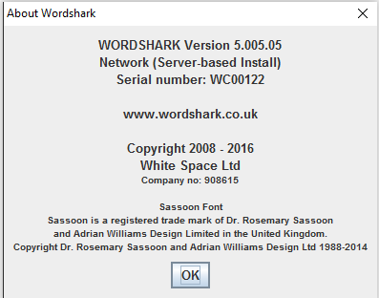Record the locations of the Wordshark folders in your network notes, and which client machines at Stage 3 deployment were allocated the full program (“Client Based Install”) and which have just a launch icon & run from the server (“Server Based Install”) note that BOTH installs access and store user data in the *wordshark-shared* folder on the server. Within the program, Help / About, you may see which of these install types is on a given client, and the version number, e.g. (Screenshot) NOTE that a trailing minus and digits, e.g. 5.005.05 – 021indicates a fault.
3. Ensure that the folder *wordshark-shared* has been added to your network schedule for regular back-ups.
4. Note for awareness that staff users can go to the program Admin / Backup & Restore if they need to backup data at other times, and Annex P gives useful “housekeeping” advice, including how to minimise server hard disk storage needs. **This is an appropriate time to remove your downloaded source files, saving around 1Gb of server disk space: The latest release of the source files can be downloaded again if and when needed.**
5. Make a note of the licence keycode and download details. The licence permits use of a single *wordshark- shared* folder, for all client machines connected (directly or via VPN/remote desktop) to a single “whole network” for a given number of “concurrent computer users”. The licence does not require annual renewal fees, and support is available for at least five years from initial purchase.
6. Make a note of what to do if staff or students lose their **program password or need to be promoted/demoted from student / Teacher / Administrator user:**
   1. **Sign on as a Wordshark administrator**
   2. **Menu: Admin / Add and manage students and staff**
   3. **Select the user (if a student, and student is not present in your list, “Collect” the student)**
   4. **With the user selected, use the functions on the top right to rename / change password / change user status.** Note that you may be asked for your OWN password as verification before changing a user status.
   5. **Advise the user of their new details, and that any user can go to menu “Settings for [username]/Password change” if uncomfortable with the password set by the administrator.**
7. *Updates and Post-Install Issues:*
   * During the lifetime of this version, free program updates are issued periodically to further improve the program. A school technician has to apply these. You may check for program updates as the Program Administrator (NOT as a Teacher or Student user) from within the program under the menu *Help / Check for Updates.* Our v5 program is now mature, and updates are infrequent: Consider scheduling an update every couple of years unless staff report an issue to you that we confirm has been fixed with an update.
   * If any “program related” issues are reported to you, please make a note to check the “Troubleshooting section which includes almost all post-install issues. The most common are error codes 98 and 99. If you are unable to find the error code within “Troubleshooting”, then email [support@wordshark.co.uk](mailto:support@wordshark.co.uk) or phone (+44) (0) 208 748 1170.
8. During the lifetime of this version, free updates to the *service* and/or *manager* may be issued to further improve diagnostics or features. See Appendix L It is worth updating the *service* and/or *manager*if migrating/reinstalling.

## Stage 4d: Set up Users

1. **Automatic Registration of Users**: The easiest method is to leave this to the program to handle automatically, as described at Stage 4a, step 5. If you have NOT set “automatic registration” and this task is to be done by a member of school staff other than yourself, go directly to Stage 4e below.
2. **Importing users from Wordshark to Numbershark or vice versa**: If you have already populated the sister program: Sign in as program Administrator, Admin / Add and Manage Students and Staff. Note left hand column of icons for adding a single student, multiple students, administrators and teachers. The “Group” icon is available to all teachers and administrators once they have registered or “Collected” students. Choose the “Multiple Students” and “Import names from (the sister program)”. Note that you can import students AND teachers, but the teachers will initially be imported as “Students” (see next point)
3. **Promoting users**: “Automatic registration” and “Import from sister program” will register all users as “Students” initially. Some of these are likely to include users who should be allowed “Teacher” rights. Whilst signed on as program administrator, in “Admin / Add and manage students and staff”, click on “Collect more students” and double-click on staff usernames to add them to your own “current students”. Then click to highlight each in turn, and “promote” them to teacher using the menu options on the right side of the screen. Note how you need to enter your OWN password to confirm you want to apply a promotion change, as well as adding a suitable password for each teacher. *This is the same utility you will probably need to use subsequently when teachers forget their passwords.*
4. **Adding teachers:** Go to Admin / add and manage. Click on the green icon to add each teacher manually
   * Hint: Use their job titles or AD usernames if possible. “SENCO” or “Class 3 Teacher” or “History HoD” usernames can more easily be given to a successor in post, who may be pleased to inherit word lists (in wordshark) or classes/work already set up (in either program)
   * Warning: Re-read the warning at Stage 4 point 4 if considering allowing any education staff “Program administrator” (red for danger icon) status.
5. **Adding students:** If you are to add students yourself manually, read [**Instructions on registering (adding) students**](http://wordshark.co.uk/Libraries/Bulk_management_of_students/ALL_PDFs_Bulk_management_of_student_names_and_files.sflb.ashx) As program administrator, register the students but **do not put them into teaching groups**: The teachers & Assistants will do this according to their own individual requirements after first “collecting” their students from within their Admin / (add and) Manage Students menu.

## Stage 4e: Handover to Education Staff

1. You have now completed the install and should have confidence in knowing you have deployed, tested and set up the program. In most cases, as installing technician, your final task is now to complete the email template at Appendix M and send the email to the primary end user, along with this document hyperlink:

[**Instructions on registering (adding) students**](http://wordshark.co.uk/Libraries/Bulk_management_of_students/ALL_PDFs_Bulk_management_of_student_names_and_files.sflb.ashx)This hyperlink links to a document that give information including “Bulk import of students”, Automatic Sign on (Shibboleth) and also includes information about bulk removal, archiving and retrieval of students & student data, and moving student profiles to and from other version 5 standalone or network products (e.g. on school transfer).

It is also worth underlining to teaching staff that they can familiarise themselves with the ‘how to’ guides and video tutorials available from our website (OR from the alternative on-server location you have installed to at *stage 4b Testing*, above)

* Using Wordshark 5:         <http://wordshark.co.uk/wordshark/using-wordshark.aspx>
* Using Numbershark 5:   <http://wordshark.co.uk/numbershark/using-numbershark.aspx>
* There are more options under ‘help’ in the main menu within the programs

1. Please also tell the end user to mention to colleagues that IF the program opens to the first splash screen but fails to complete loading, it is failing at the point where it checks (by saying "Hello") that the sound is working. The teacher will need to check that speakers or headphones are plugged in and functioning. Mention too, that for Wordshark a microphone can be very useful: It is needed for one game (“Say Word”) and also needed to record sounds under “Actions /Own Word Lists”.

Navigate to: Contents Instructions Stage 1 Stage 2 Stage 3 Stage 4 Trouble-shooting Contact

## CONTACTS: How to Obtain Support

**Contacting Support:**

**Phone:** 020 8748 1170

Outside the UK:

(+44) 208 748 1170

**Email:** [support@wordshark.co.uk](mailto:support@wordshark.co.uk) **Skype**: wordshark.support

Opening hours: 9-5 UK weekdays. “Out of hours” calls 8am to midnight UK time may be arranged if needed.

If phoning us, please be ready to leave your name and contact details and best times/means of contacting you, as we may be helping other customers.

Tell us if you are a visiting technician with a specific visit timeframe.

We can contact via [email,](mailto:support@wordshark.co.uk)landline and (UK only) mobile phone. We can offer remote internet support via [www.logmein123.com](http://www.logmein123.com/) if your security policies allow this.

**If the trouble-shooting hints in** **Appendix A** **do not help quickly, please contact us rather than waste your time.**

**The purchase price covers the cost of the software, with the requirement that the school’s own IT support staff then downloads, installs to the server and deploys to client machines.**

**Should the installing tech experience any issues, or if there are issues post-install, our own support team can provide reasonable support of up to two hours is provided, with further support at the discretion of our Support Manager up to five years after initial purchase. This support may be by email, phone, or remote internet support via** [**www.logmein123.com**](http://www.logmein123.com) **(the latter provisional on the school’ own proxy/firewall/security permissions allowing access to this service)**

***Here is a list of information that we find particularly useful: The more information you can provide, the better we will be able to diagnose the issue & support you:***

1. Your Organisation/School name and Location as in your licence details.
2. Your phone / email / name for us to contact you.
3. Are you in mid-install, or has the program suddenly malfunctioned after working for a period? Have you migrated servers recently, or otherwise made changes?
4. Tell us about your infrastructure: What server / client OS you have, wired / wireless / both wired and wireless. Physical or virtual server/clients? Terminal Services? Is it a non-standard Windows network (e.g. Ergo, CC4)
5. Which *manager* release you are using? (this is shown on the top menu bar, or in Control Panel add/remove programs: Look for “White Space Network Management XXXX, where XXXX = version number)
6. Screenshots / details of any error messages seen can be invaluable.
7. 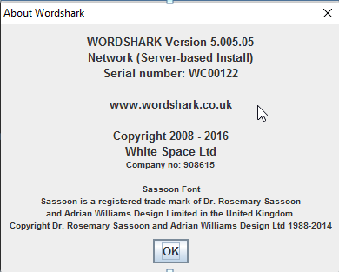Check your server Event Viewer Windows Log / Applications for any errors. Screenshots of suspect areas may help us to pinpoint the issue.
8. Tell us whether the *manager*, *service* and *wordshark-shared*

are all on the same server or otherwise

1. If you can sign into Wordshark as an administrator:
   * Go to *Help / About* menu and quote the exact release, e.g. Wordshark 5.005.05-12. It is particularly helpful to include a screenshot (see example)
   * Go to the *Admin / Advanced Features / Create a zipped copy of the wordshark-shared* folder menu and choose the *‘anonymously’* option to remove personal data. A zipped folder is created on your Desktop. Please email this to us, if possible even before phoning.
2. Otherwise, find the *wordshark-shared* folder on the server, zip the whole *wordshark-shared* folder & email to us. If too large and any of the following are present within this folder, please zip these up as a minimum:
   * “*Diagnostics*” folder
   * “Config” folder
   * “D9SLD83.xml” file
3. A screenshot of the expanded server registry entries (for the server hosting the *wordshark-shared)* contained within *HKEY_LOCAL_MACHINE\SOFTWARE\[Wow6432Node if a 64 bit machine]\White Space Ltd\Networks\Wordshark 5*

Navigate to: Contents Instructions Stage 1 Stage 2 Stage 3 Stage 4 Trouble-shooting Contact

# Appendix A: Trouble-shooting (including common errors and error codes)

This appendix covers the majority of issues involving network installation and subsequent running that are reported to us, and explains how to obtain support. This appendix comprises:

Service, Manager & Activation Issues

Numbered Error Codes

Other Issues

Migration deactivation

How to obtain support

**Service, Manager & Activation Issues:**

**The *service* and *manager* fail to install or run, perhaps with “****Error 1920 Failed to start White Space service” or “Unhandled Exception:** This can be for several reasons, and it is worth checking the server Event Viewer often helps to trace the cause.

1. **You were not signed on with Domain Manager Admin Rights.** You need these rights to enable the

*service* to install/run/make the necessary registry changes and install programs onto the server.

* + 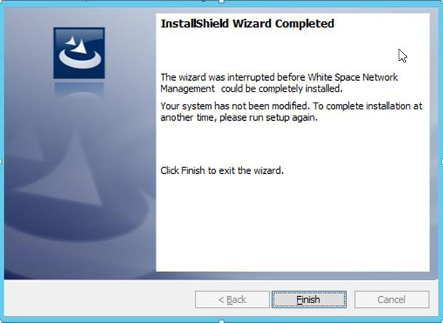**The program may start to install, but then fail and roll back.** This only occurs with old releases of the installer. If the install of the *manager* fails and rolls back, possibly with a “timeout waiting for Service” or similar displayed in the Event Viewer, **Update** your *manager* and *service:* See Appendix L
  + If updating is not possible immediately, then reinstall using your existing MSI, but mid install ensure you add your username/password to the screen where you previously chose “Log in as Local Admin”. If this fails, then first open the “Services” on the host server, and re-run the MANAGER MSI: This time, as soon as the service “White

Space Network Management” opens, click on its properties, and ensure you enter the correct login credentials including username/ password for Local Admin (Domain Manager).

1. 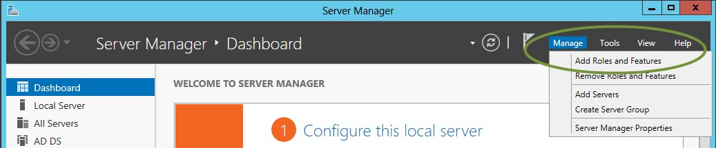**The correct version of .NET Framework, v4.7.2 or later, is not enabled or not installed**: This is used by the *manager*. Note that earlier .NET frameworks can co-exist, but these do not contain the required utilities -see also side note in box. See the “Required Specification for Server”. .NET is normally pre-installed but may need to be enabled. *(see screenshot below, showing v3.5: v4.7.2 has a similar screen) There is no need to select HTTP Activation or Non-HTTP Activation.* If you attempt to download and install, you may see an error “**You must use the Role Management Tool”** or **“The wizard has been interrupted”**[after which the install stops and rolls back]Instead of installing, enable the already- installed .NET Framework 4.7.2

Earlier .Net than v4.7.2?

[Contact Support](mailto:support@wordshark.co.uk?subject=Need%20the%20old%20S&M%20v1.0.8.0%20as%20we%20are%20%20using%20.Net%203.5) for a version of our *White Space Network Manager and Service* that use the old .Net Framework 3.5

1. Ensure you have admin rights (and disable UAC which can give issues)
2. On the server: Go to Server Manager/ Click on Manager (top right) / Choose “Add roles and features / Server Roles / Features (greyed out originally)(*not the “roles”)*

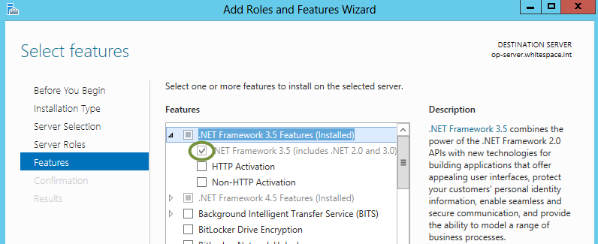

1. 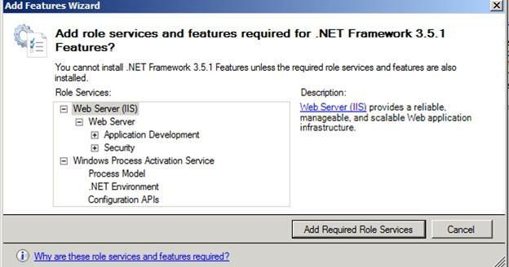Fill the checkbox for .NET Framework 3.5.1 (if using the OLD Service and manager 1.0.8.0) or 4.7.2 (for our current Service and Manager v2.0)
2. Click button “Add Required Role Services”
3. NEXT to enable. Accept defaults with further NEXT. Verify that the .NET Extensibility check box is selected by default, and click Next
4. Wait for install to complete and click to close.
5. Try reinstalling the *service* and *manager*

again.

1. If you have deactivated UAC, turn it back on to avoid falling foul of local security requirements!
2. **The account under which the Service runs has inadequate permissions, or suffers a logon failure:**

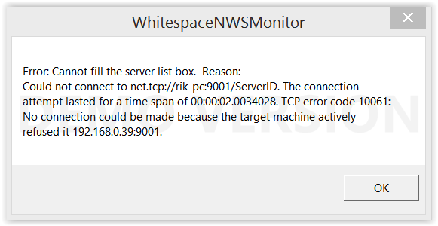The *service* installs first, then the *service* is started, and finally the *manager* is installed. If the *service* installs but fails to start, the *manager* will not run properly. It will produce a message: **Error: Cannot fill the server list box.** This usually refers to being unable to connect to a net .tcp address. There will usually be a “timeout waiting for Service” error in the Applications Event Log when the *service* attempted to start. is usually followed by “Unhandled exception”.

A similar message occurs when trying to start the *manager*

if the *service* status is not “running” or is **awaiting a restart**\**.* Press “Quit”, and restart the *service* (listed under “Services” tab as White Space Network Service”) from within Task Manager. Restart the *manager*, which should now open correctly.

**\*If awaiting a server restart**, the *service* status may show as “Started” (not “running”). In this state it is not possible to “stop” or “restart” the service. Reboot the server, restart the *White Space Network Service*, and check the *service* status changes to “running”.

The Event Viewer may show errors for WhiteSpaceNetwork including a comment on the “General” tab of “Service cannot be started … Server execution failed. Again, If it does not, then the usual cause of this problem is that the account under which the service is running has insufficient 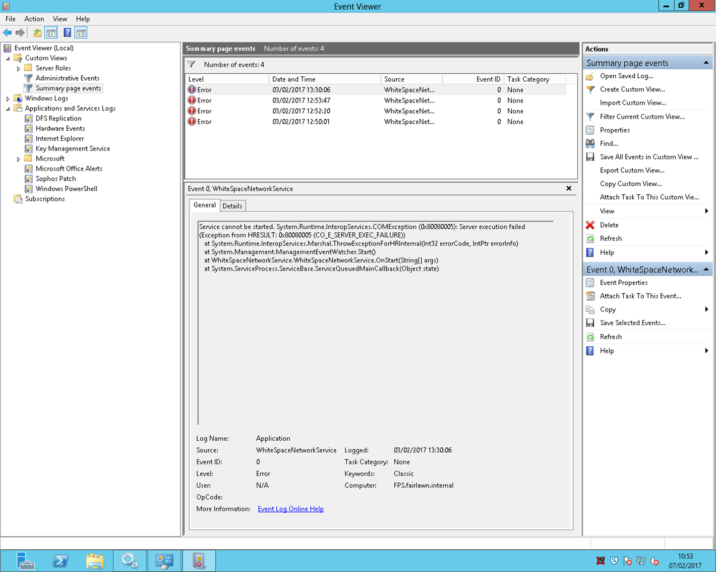privileges to make necessary file or registry changes, or the username/password combination provided to the service is incorrect. In many cases the default “Local Admin” account will work, but otherwise choose an account with sufficient privileges to change files and registry entries. You may need to set up a special account. To change the account details under which the service runs you may either:

* + Reinstall, but mid-install ensure you add an appropriate username/password to the screen where you previously chose “Log in as Local Admin”
  + Change the username/password in the services applet, looking at the properties of the *service* from the services applet. This is most easily reached by typing SERVICES into the Windows search box (or start screen in Windows 2012).
  + 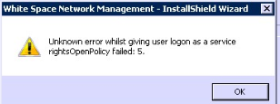Rarely, the White Space Network Management-InstallShield Wizard may display a message “Unknown error whilst giving user logon as a service rightsOpenPolicy failed: 5. This has occurred when a virtual server has been set up: The tech is signed on with domain/top level rights BUT the person setting up the server has not yet switched on the rights for that user to run with Local Admin Rights. Perform the following to edit the Local Security Policy of the computer you want to define the ‘logon as a service’ permission:

1.Logon to the computer with administrative privileges.

2.Open the ‘Administrative Tools’ and open the ‘Local Security Policy’

3.Expand ‘Local Policy’ and click on ‘User Rights Assignment’

4.In the right pane, right-click ‘Log on as a service’ and select properties.

5.Click on the ‘Add User or Group…’ button to add the new user.

6.In the ‘Select Users or Groups’ dialogue, find the user you wish to enter and click ‘OK’

7.Click ‘OK’ in the ‘Log on as a service Properties’ to save changes.

Ensure that the user which you have added above is not listed in the ‘Deny log on as a service’ policy in the Local Security Policy.

1. 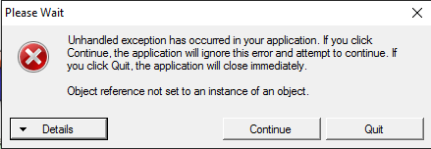**The** (case-sensitive) **wordshark-shared folder cannot be found:** This is normally due to incorrect sharing/permissions/security/path to the server *wordshark-shared* folder. This *may* flag up via a message “**Unhandled exception: Object reference not set to an instance of an object”** (see screenshot). The “Details” button may give the message System.NullReferenceException: Object reference not set to an instance of an object. at WhitespaceNWSMonitor. StatusForm. StatusForm_Load( Object sender, EventArgs

There are several possible reasons:

* + The program was not installed using the correct MSIs but as a copy and paste install
  + There is a *wordshark-shared* folder inside another *wordshark-shared* folder, and this “nesting” has confused our program! Uninstall and reinstall the S-Server MSI
  + The path to the *wordshark-shared* folder includes a $ and the service cannot locate it
  + The program has been installed to a mapped drive and not a UNC path
  + The *wordshark-shared* folder does not have the correct permissions: Folder/NTFS permissions of read/write/modify and delete for all users
  + The folder need to be shared **via *Advanced sharing***(this may need to be enabled on the server) and share permission set to *Full control* for *Everyone*
  + This can also happen if the installing MSIs have been run from a remote machine and not directly on the server, as this can put the required registry entries on an incorrect machine.
  + Rarely, if sharing was incorrectly set, there may be more than one instance of the folder *wordshark-shared,* e.g. *wordshark-shared(1*). This can confuse our *service/manager*: Ensure there is only one instance of the shared folder.

We advise that you:

a) Check sharing, permissions, and in particular, hidden sharing. See the main instructions Stage 1 and note that if using Server 2008 a $ in the path is not permitted.

1. Check the permissions listed in Appendix H. If the *service* is unable to access/write to this folder, it may shut down. If the *manager* is unable to find the *service* it may close. The server Event Viewer may flag up missing or invalid paths/folders. Note that these need UNC paths, even if “Installer” messages appear to allow paths such as d:\White Space……..\etc.
2. **Check the registry entry for the *wordshark-shared* folder** using RegEdit: On the server hosting the *service* and *manager* check that the relevant product is listed: HKEY_LOCAL_MACHINE\SOFTWARE\ [Wow6432Node if a 64 bit machine]\White Space Ltd\Networks \Wordshark 5 should contain:

(**Default**) (value not set)

**Code** Should be WC for Wordshark 5.

**EPN** Should be a set of alphanumerics: Contact Support if this is empty.

**SharePath** Requires a UNC path, finishing \wordshark-shared (re-check spelling, and note all lower case)

d) **Restart the *manager*,** and within the *manager* click on the “Files and Folders” tab to “Save and Restart Service” to allow both to repoint to the correct location of the user data folder *wordshark-shared.*

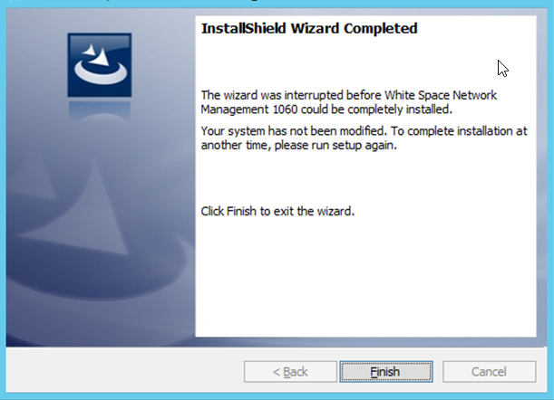

1. **The SERVICE and MANAGER fails and rolls back** with this error message: A time out message will normally appear in Event Viewer. The time out message in Manager will be given where the service can’t start because: it has been set to manual, the user credentials are no longer valid (e.g. password needs updating or privileges removed to start services) or other problems that will only show in diagnostics or Event Viewer (e.g. no isolated storage).
2. **The SERVICE** fails for any reason: Restart the *service*. To restart, open the *manager* and click the “Start” button on the “Service Details” tab. **If the service is not running the manager will not open.** We advise you monitor this. If it fails again for no apparent reason, try setting to “Automatic Delayed Start” or extending the server’s timeout value* to 240 seconds or longer normally resolves the issue, unless there has been a password change affecting the Service.

[* Click here for a useful web hint on extending timeout value](https://support.microsoft.com/en-gb/kb/922918)

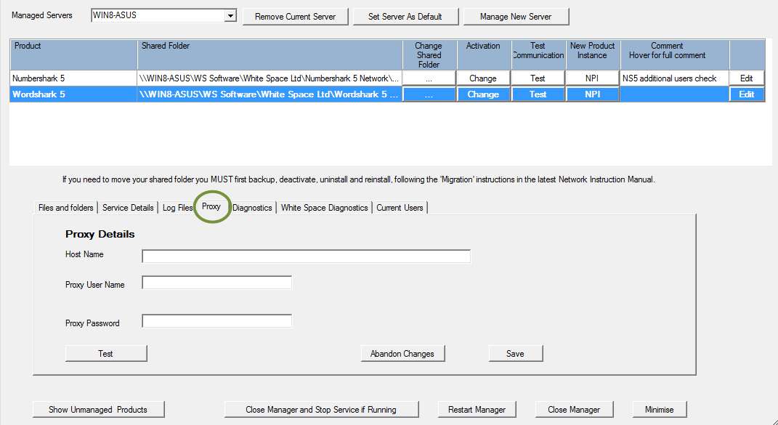**Activation Fails:** This is normally due to proxy settings preventing access. Ensure you are using the latest *manager*, select the “Proxy” tab, and fill in the proxy server username and password. Problems activating on-line can occur if you have a smoothwall filter and the proxy with port 8080 is heavily filtered. Input a different port into *manager* and you may find this works better. You can alternatively activate using the “Proceed with off line activation” process but this is a slower process.

1. **Network Port 9001 not available for the program to use**

If port 9001 is already in use for a different application, Windows Event Viewer or other errors mentioning socketpermission or socket.error or socket permission may be seen. Ports above 9000 are rarely used, so most are usually available.

Port 9001 is used ONLY for internal communications between the Service and Manager (Self-hosted WCF).

Activation may be easier if you whitelist [www.wordshark.net](http://www.wordshark.net/)



Click the “Test” button: The manager will NOT load if the service cannot communicate with it so if it opens and shows the products then we KNOW port 9001, or whichever one in use, is working. If internet access is also working then you’ll get a ‘Test communications successful’ message.

If there is no internet access then the following message is given:



**If from this you realise your Proxy name, username or password are incorrect, you may change the proxy settings within the White Space Network Manager “Proxy” tab:**

Proxy settings:

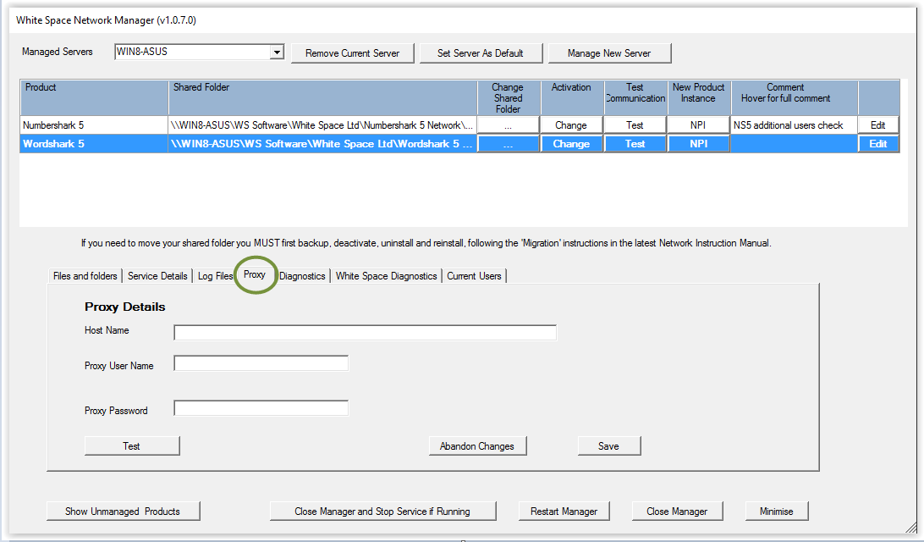

**Preferably,** uninstall the Service and Manager, download the latest release and install, specifying a different (available) port mid-install. Alternatively open the manager program. On the “Service Details” tab, change the Service Port to an unused number. On the Proxy tab, correct the account details. As with any change, restart the service and manager using the “Start” button shown below and the “Restart Manager” button.

In one school with a ‘smoothwall’ filter, problems activating on-line were due to the proxy with port 8080 being heavily filtered. After inputting a different port into wordshark network manager/Proxy/Host Name, the activation worked.

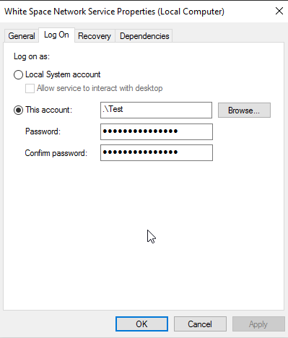

Rarely, the “**Local System account**” user account logon is not accepted: Go to the server “Services”. Find the White Space Network Service. Left-click “Properties”. Choose Log On tab, and try the most senior admin account you are permitted:

1. 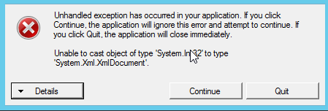**Service and Manager install and activate, but after some use fail to open with an “Unhandled Exception message that reads as per screenshot:**  This is the one occasion where we recommend that you delete the .xml file in the root of the wordshark-shared directory, and then attempt to restart the Service and reopen the Manager. The .xml file will be recreated from a hidden backup and this will normally clear the error. If it does not, contact support without delay.

Navigate to: Contents Instructions Stage 1 Stage 2 Stage 3 Stage 4 Trouble-shooting Contact

**Error Codes:**

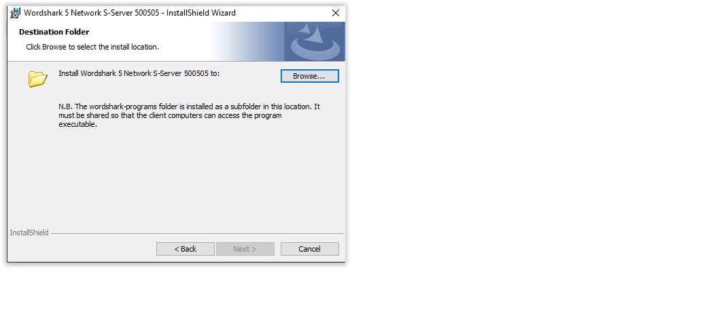**Error Code 6:** The folder wordshark-programs, along with wordshark-public, need to be within the same shared folder (e.g. *wordshark 5 network*). If these two folders are each shared separately, they will not be able to find each other, resulting in this error. (See screenshot). The error also occurs if the desktop icon “Start-in” path is incorrect (see error code 9 below)

**Error Code 9:** Most commonly results from a desktop icon whose Properties/ “Start in” path does not point to the server *wordshark-shared* folder. This *must* be lower-case. Correct this, restart the SERVICE and manager. Attempt to run the program again. *This also occurs if accessing via VPN or RDP to Server 2016: This is permitted, but contact Support for advice.*

**Error Code 10:** results from incorrectly set permissions. Check Appendix H. Note 1: This will also happen if attempting to access the program via VPN or Remote Desktop and permission for access has not been set on the individual client machine. Note 2: Impero, Ranger, or

standard Windows networks using MS File Screen Manager may also experience this during OR AFTER install, if the path to *White Space Ltd* has not been added to their Exemptions List.

**Error Code 23:** Normally, this is a “typo” as a key code is incorrectly typed. Sometimes, the licence key code for Wordshark has been entered instead of the one for Numbershark – or vice versa.

**Error Code -34: (Error getxmldocument)** The file *D9SLD83.xml* in *wordshark-shared* is missing or is blank. This is usually because incorrect permissions have prevented it being written to. Check permissions are read/write/modify/delete for all groups of users. Run the S-Server MSI again to recreate the XML file. If this still fails, [Contact](#supportcontact) Support

**Error Code 56:** The program is unable to see/read our files. This usually means that there is an issue with the sharing permissions of the mapped drive, or it has been hidden with a $ used inappropriately.

**Error Code 59:** This commonly happens if:

1. You have not yet activated the program (using the “Activate” button on the *manager*)
2. The folder *wordshark-shared* has been moved without similarly changing the path in the “Start-in” and in the *manager*. Correct this. Restart the *manager* and *White Space Network* *Service*, and attempt to ACTIVATE the program using the “Activate” button on the appropriate software product.

**Error Code 66:** This means that the client machine has not been able to validate the licence token, which is provided by the *service.* Check that the *White Space Network* *Service* is still running. Check, if NOT on Active Directory, that the server and clients are set to the same time zone and time (within 5 minutes). If these do not clear the problem, contact support.

**Error Code 69:** The licence was unable to be validated. Check that the *White Space Ltd* folder, *wordshark- programs* and *wordshark-public* have “read” permissions. Most other reasons for this issue were identified and are self-repaired by *manager* 1.0.6.1 and later. If you have a previous *manager,* please update.

**Error Code 70:** The licence has not yet been activated. As part of the install process, you need to install the *service* and *manager,* and activate the licence. Return to Stage 2 of the instructions. Rarely, the Wordshark program and the Manager/Service are looking at ***different*** *wordshark-shared* folders. Ensure the “Start in” path in the desktop launch icon is the same UNC path as showing in the *White Space Network* *Service* and *manager.*

**Error Code 98 & Error Code 99:**

**Error code 98** occurs if the licence cannot be verified, and isdisplayed to teachers/program administrators when they log on. Under the “Help/About” the version will indicate a “countdown” after the version number. e.g “Version 5.006.02 -023” would indicate the program is likely to stop working in 23 days if the program is not able to self-repair in the meantime.

**Error code 99** follows several weeks of “Error Code 98” warnings, and the program will close after approximately 2 minutes. The Help/About” version will indicate a countdown of zero days, e.g. 5.006.02 -000.

**Both** error codes normally occur if our *White Space Network* *service* has stopped running. A restart of our *White Space Network* *service* usually resolves the issue: The usual cause is that major MS server updates can take longer to apply than the default time-out for services: We suggest if you need to restart to apply a server update then you do this TWICE – once to apply the updates, and a 2nd restart to give ***all*** services time to restart. Setting to “Delayed start” or extending the server’s timeout value to 360 seconds or longer can help if you have a slow / old server overloaded with many services.

**Rarely,** the *service* is prevented from opening if your local security policies are commendably secure. Cases have included:

* “local Admin” password has been changed.
* you are running policies or software or File Service Resource Manager Screening to guard against “Crypto-Locker” and other ransomware threats which as a side effect block the Local Services account (SYSTEM user) or in other ways affect the opening of services.

**If the *White Space Network* *service* is found to be still running, OR if a restart of the *service* fails to clear the error code**, then a more complex diagnosis and repair is indicated so you will need to contact Support without delay, change as little as possible in the meantime, and if possible send a zipped copy of your *numbershark-shared* folder (as this stores the diagnostics for both programs). If you ONLY have Wordshark installed, then diagnostics will be inside *wordshark-shared* and this needs to be sent instead.

**Error Code 108:** No isolated storage found: Normally resolved by sharing *wordshark-shared* and giving "Everyone" advanced sharing permissions of “Full Control”, and “Security” similar permissions. Check, too, that the time on the server is correct and you are in the right UTC Time Zone, and that the Region/ Formats tab is set to “Match Windows display language”.

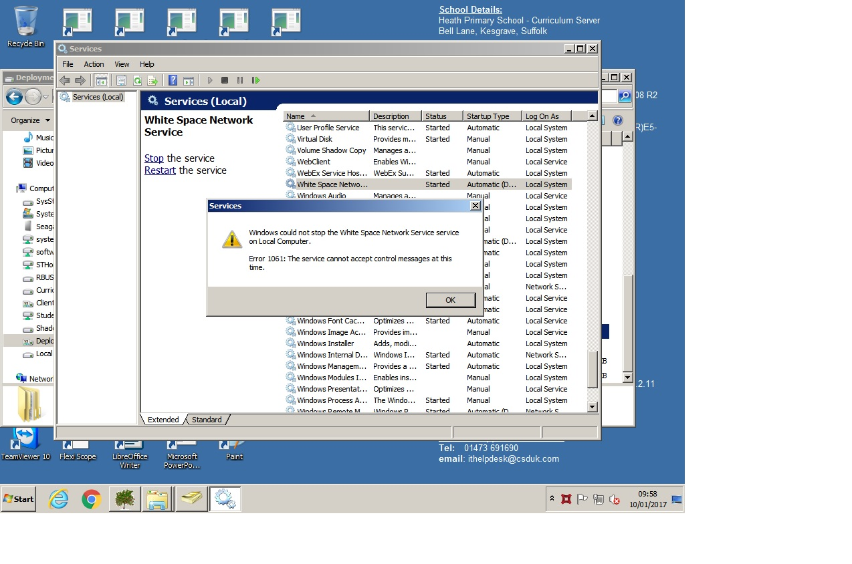**Error Code 271:** Similar symptoms and actions to Error -34 above.

**Error Code 248**: Same resolution as Error Code 23, above.

**Error Code 1053 The service did not respond to the start or control request in a timely fashion.**

**Error Code 1061 The service cannot accept control messages at this time:** (See picture) Both of these are Windows errors that normally indicate a need for a server restart following a Windows update. These are often coupled with the status of many services (not just our own White Space Network Service) showing as “Started” rather than the normal “Running”. In this state, it is not possible to “stop” or “restart” the service. Reboot the server, restart the *White Space Network Service*, and check the *service* status changes to “running”. Further info from Microsoft: <https://msdn.microsoft.com/en-us/library/windows/desktop/ms682108(v=vs.85).aspx>

* **If the server restart does NOT fix the “Error Code 1053”, and you are aware that the server is particularly slow, setting our service to “Delayed start” usually works. In extreme cases, where other services are also failing to start, it may be necessary to change the default time-out for all service starts.** [**https://support.microsoft.com/en-gb/kb/922918**](https://support.microsoft.com/en-gb/kb/922918)
* **If the server restart does NOT fix the “Error code 1061” it may be due to disk space issues preventing writing to the service’s log file.**

**Error Code 1305:** Usually with a message about being unable to read files. *Either* the download is incomplete/corrupted or did not extract correctly *or* trying to run the MSI without the program files folder in place. For example the C-Client MSI was moved to the client machine but the program files folder was not also moved across.

**Error Code 1309:** occurs if you try to install onto a client from a remote server, so that the extracted files are in an inaccessible cache **OR** the program files folder has not been included with the installer MSI-see Appendix J

**Error Code 1325:** This is normally resolved if you use UNC paths (as required) instead of a mapped drive.

**Error Code 1603 (during silent deployment):** May be incorrect permissions on an Ergo Free to Teach server

([product requires packaging by Ergo](http://www.wordshark.co.uk/Downloads/WS5N)). Other reported reasons on standard networks for this Windows error

**Error Code 1606:** means the installer cannot locate the folder, either it does not exist or the path is invalid.

**Error Code 1920: - Failed to start service** Either .Net Framework 3.5 is not enabled OR port already in use. May also be due to no shared folder - product not installed or incorrectly installed (possibly due to hidden paths with $). Further details

**Error Code 1722:** usually caused by incorrect permissions to extract from current location, OR file has not downloaded correctly. For RM schools only: A multi-site or multi-server school where the RM Public and RM Shared are either not the same server OR are named differently.

**Error Code 2711:** This occurs if you install a *C-Client MSI* to a client machine where one is already present.

**Error Code 0x80010135:** means that the path is too long to complete installation. Normally only seen in the Event Viewer, this is not usually an issue during a manual installation as it tells you what it cannot do. If performing a silent install onto a very long path then the install would just fail.

**Event Viewer Event ID7030:** with messageThis may be fixed by ticking the box on the White Space network Service “properties” to “**allow** **service to interact with desktop”.**

**Other Issues:**

**Program Closes at Launch (no error):** Wordshark requires a working sound card. Windows 7 and Windows 8 clients’ soundcards are often disabled if speakers/headphones are not plugged in/switched on. Wordshark will attempt to display an error message if unable to access a working soundcard, but close after 10-20 seconds on the initial splash screen. See also [www.wordsharksupport.co.uk/network-fizzle-after-splash-screen.html](http://www.wordsharksupport.co.uk/network-fizzle-after-splash-screen.html)

**Exemption Lists:** If your network restricts the executables that users may run, and depending on your network security, you may need to allow execute permission to *Wordshark5nrun.exe* (in the *wordshark-programs* folder) and *javaw.exe* (in the *wordshark-programs\bin folder*) before running.

**Slow loading:** If the program takes more than approx.15 seconds to load to the login screen, then this is often a symptom of a network overload and/or “Scan on demand” high level anti-virus settings. Consider moving to a *Client-based Install* instead, as described in Stage 3 See also *“Special Situations*”

**Administrator or student details disappear**: You have not given the staff/students read/write/modify/delete access to the *wordshark-shared* folder, OR, if student details are not saved, check if you have a “sandbox” resetting machines, and see next point “Temporary Students”/

**Temporary Students:** After signing onto the program users see a message about being “**Temporary Users**”: They have access to all games & word lists, but are unable to create word lists, and no data is stored for them.

Any Wordshark administrator can prevent students signing on as temporary users in the ‘Sign-on Settings’ of ‘Universal Settings’. **We recommend that “temporary students” are normally disallowed.**

If no ‘temporary’ students are allowed AND students are registered to the program using Active Directory usernames AND 'Automatic sign-on' is chosen (also found in the 'Sign-on Settings’ of 'Universal Settings'), issues with students mis-typing their names are minimised.

**Warning Messages to Users:** If the program detects an issue but is unable to self-repair, it may flag this message to Wordshark administrators and teachers, **and later to all users:**

This program has encountered a problem. Please contact your network manager in order that the program continues to run. Trouble shooting guide: [www.wordshark.co.uk/support/net500](http://www.wordshark.co.uk/support/net500)

If this message is reported to you, proceed as for “Error code 98” above. If not acted on promptly, the program may stop functioning, displaying a message which is equivalent to” Error code 99”:

This Wordshark installation is no longer able to run. Please contact your network manager.

Trouble shooting guide: [www.wordshark.co.uk/support/net500](http://www.wordshark.co.uk/support/net500)

**Lost Passwords**: If staff forget their passwords, sign onto the program and reset, using your user details you created at stage 4 of the installation process. For further guidance see the “Help” menu .PDF “Printable manual”.

**Usernames with non-English characters:** If using an English keyboard, the default for user names to be shown on the right of the sign on box must be left on. The user can then be selected from the list as the standard onscreen keypad does not include accents. Adding your own keypad does not work as these will only appear in games when the accents are required for words within the lists.

**Index out of the bounds of the array:** Actual message: *“Service cannot be started. System.IndexOutOfRangeException: Index was outside the bounds of the array at WhiteSpaceNetworkService.WhiteSpaceNetworkService.OnStart(String[] args)*

*at System.ServiceProcess.ServiceBase.ServiceQueuedMainCallback(Object state)”*

means the program received an unexpected response. This is usually an issue relating to initial installation:

* There is only one product and this has been excluded – delete the exclusion line in regedit under Manager – This is the most common reason.
* The server has been renamed or changes made to it so the original activation can no longer be verified
* The –shared folder and service are on different servers and the service cannot find the shared folder

**Object reference not set to an instance of an object:** This means that the service is unable to locate the *wordshark-shared* directory. There are several possible reasons:

* The program was not installed using the correct MSIs but as a copy and paste install
* The path to the *wordshark-shared* folder includes a $ and the service cannot locate it
* The program has been installed to a mapped drive and not a UNC path
* The *wordshark-shared* folder does not have the correct permissions:
* Folder/NTFS permissions of read/write/modify and delete for all users
* The folder need to be shared via *Advanced sharing* and share permission set to *Full control* for *Everyone*
* This can also happen if the installing MSIs have been run from a remote machine and not directly on the server. This can put the required registry entries on an incorrect machine.

**Migration to new server or replacement server: Failed to deactivate first.**

* The licence activates to a single specific instance of the *wordshark-shared* folder.
* If you wish to **move the folder, rename or rebuild the host server, or migrate to a new server, you MUST first deactivate the licence.**
* **Failure to deactivate may result in loss of the licence or a charge for a replacement licence.**
* You may relicense your licence to a new location up to five years from initial purchase.

If you have migrated to a new server without deactivating the licence, you will find that you are unable to complete activation (part way through Stage 2) as your licence is still activated to the specific instance of the *wordshark-shared* folder on the old server.

* We also find that in such cases, a tech may have tried copying the old, out of date, version 5 files instead of updating to the latest files If you have done this, we suggest you delete the copied files and start again using the advice within [**Appendix I**](#Appendix I:   Upgrading / Updating  / Migrating or Rebuilding Servers)
* If the old server is still usable, with our program still installed, then return to it and ensure that our “White Space Network Service” is running. Load up the “White Space Network Manager” application, click on our programs (in turn if you have both Wordshark and Numbershark). Click the “Change” button and follow the on-screen instructions to deactivate (this is most easily done if the server is still internet-connected, but may also be done “off – line”).
* If the old server is still usable, our program is installed but the “Change” button is missing, and you only see an “Activate” button, then we recommend that you *uninstall* the Service & Manager, and install the latest Service and Manager. This has maximum ability to detect and allow deactivation.
* If the old server is still usable, but our program is no longer installed, please reinstall following the stages 1 and 2, using the latest MSIs linked at Stage 1. This will permit activation/deactivation.
* We can normally support most effectively if you are able to arrange for us to give remote access support over internet. Without such access, advice by phone or email is available, but success is less certain.
* If the old server is NOT usable, so you are unable to deactivate, e.g having already been decommissioned, destroyed by fire or otherwise, please contact Support and advise us of the circumstances. In most cases, Support can recommend to Sales that they offer a replacement licence at a “Replacement Licence” cost, which is less than the normal cost of a licence.

Navigate to: Contents Instructions Stage 1 Stage 2 Stage 3 Stage 4 Trouble-shooting Contact

# Appendix B: Licence & related FAQs & Server Migrations/Rebuilds

This page includes FAQs on server migrations, licence expiry, load-balancing and home-access and repeats licence terms given on our website at time of purchase.

A Licence Key has been sent to your organisation via email). The code is needed whenever activating or reactivating your installation. After activation is complete, please store it in a secure location. This network product and licence requires computers to be connected to a Windows Server network. Alternative formats of the program are available for use on standalone computers or computers that are used both on and off the school network. The licence sets out the total number of concurrent users owned by your organisation. This information is also displayed on-screen in the program.

The program may be deployed to every client on a single network served by a single data server for a single school. Each user logged on at a given time uses one of the user concurrent licences. The program automatically counts the number of concurrent users, and limits access if the licence number is exceeded. Technicians may find useful the *Users/ List of users* menu, which shows every computer name and username(s) currently using the program. This is located in the “Users” menu.

**FAQ 1: “Can I** **migrate this licence to a new server?” “Can I use this licence on several servers?” “Do I have to remember to renew the licence each year?” “Does the licence last for ever?”**

**Answer**: If changing the server hosting the *wordshark-shared* folder, you **must** first deactivate the licence as it can only be registered & used on one server for one instance of the *wordshark-shared* folder at a time. Deactivate by opening the White Space Network Manager on this server, clicking on the “Change” button, and following the on-screen instructions to deactivate. Follow migration advice at  [**Appendix I**](#Appendix I:   Upgrading / Updating  / Migrating or Rebuilding Servers) after which the licence can then be reactivated to the location of the new data folder on the new server.

* The licence activates to a single specific instance of the *wordshark-shared* folder.
* If you wish to **move the folder, rename or rebuild the host server, or migrate to a new server, you MUST first deactivate the licence. See**  [**Appendix I**](#Appendix I:   Upgrading / Updating  / Migrating or Rebuilding Servers)
* ***What to do if you have omitted this step***
* **Failure to deactivate may result in loss of the licence or a charge for a replacement licence.**
* You may relicense your licence to a new location up to five years from initial purchase.

We suggest you use the migration as an opportunity to update to the latest MSIs, following the instructions in the “upgrade” section Appendix I and Stages 1-4 .

Your licence does NOT require an annual renewal fee, has no expiry date, and is fully supported for five years from date of initial purchase (not date of any subsequent purchase of additional licences). We are not able to offer full support or the ability to deactivate/reactivate licences beyond the five-year anniversary.

**FAQ 2: “Can children and staff access this server-based program from their homes?”**

**Answer:**

**Home Access** is permitted, though not explicitly mentioned on the licence sheet. If your organisation has home access to server-based software, e.g. via Terminal Services, VPN or Citrix, they are permitted within the terms of our network licence agreement to use this product remotely from home. Subject to bandwidth and latency, this can work well. We are however unable to support users accessing our software remotely.

We have a sister product to Wordshark, “Wordshark OnLine” which is a completely separate product with an annual subscription. This is cloud-based, running in a browser, and compatible with many iPads, Chromebooks, Mac and PC computers. Details available from [www.wordshark.co.uk](http://www.wordshark.co.uk). There is not an equivalent for Numbershark.

**FAQ 3: “I want to use several servers to run the program. Is this permitted?”**

**Answer:**

**Yes: Load-balancing** is permissible under terms of the network licence, though not explicitly mentioned. Several servers may be used to run the program (e.g. to serve terminal services / thin clients), but only ONE instance of the data folder *wordshark-shared* is permitted. For details and instructions, see APPENDIX C, SPECIAL SITUATIONS.

Navigate to: Contents Instructions Stage 1 Stage 2 Stage 3 Stage 4 Trouble-shooting Contact

# Appendix C: Special Situations inc. Load Balancing, Linux, VPN, Virtualising to Devices

*This appendix includes:*

***Server & Manager on 1 server, Data Shared folder on 2nd server***

***SLOW LOADING***

***LOAD-BALANCING***

***Use of SAMBA/LINUX Servers***

***VPN, Remote Desktops and virtualising to iPads, Macs, Android devices***

**SCCM deployment is covered in** **Appendix N**

*If you are installing into a “large infrastructure/multiple schools” situation (e.g. multi-school group, council or state-wide server farm or similar, see also****Appendix K*** *which gives further guidance and options for situations where several instances of either program will be located within the same server / server farm.*

**Server & Manager required on 1 server, User Data Shared folder on 2nd server:**

Whilst we advise that our *Service* and *Manager* (S&M) are located on the same server as the user data folder *wordshark-shared* or *numbershark-shared,* they CAN be located on a different server

*In the instructions below, the data folder wordshark-shared is on the “DATA server” and the S&M are on the “LICENCE” server.*

NOTE that you have to carry out the following points in order, as the S&M will not open unless the correct registry entries have been created on the server the S&M are to run on. These entries are created by running either the S-Server or C-Server MSI on that server.

1. Read stages 1-4 of the main instructions as an overview but **note the points below which vary from the main instructions.**
2. On the DATA server, manually create a folder, e.g. *Wordshark.* 
   * this can beinside a hidden share
   * If multiple schools share use of the DATA folder, this may be within a school - specific folder e.g. \\APPServer*St Marys School\Wordshark* Repeating step 5 below for other schools will create multiple shares, e.g. *wordshark-shared, wordshark-shared2, wordshark-shared3.* **NOTE** that at Stage 3 of the install, you will need to specify separate paths for the desktop icon start-in addresses such as:
     + \\APPServer*StGeorgesSchool\Wordshark\wordshark-shared*
     + \\APPServer*St Marys School\ Wordshark\wordshark-shared*
     + \\APPServer*CuthbertHillSchool\ Wordshark\wordshark-shared*
3. Then follow Step 1 of the main instructions to ensure .Net Framework 3.5 is installed / enabled on the LICENCE Server.
4. On the LICENCE server, run one of the following MSIs to create the required registry entries on the LICENCE server: For either MSI, mid-install, you will be asked for the required location of the data folder *wordshark-shared* (**exact words, case sensitive**). Specify the folder you have created on the DATA server. The MSI will then create the *wordshark-shared* data folder inside this folder.
   * Run just the **S-Server MSI** if you want to install the wordshark-shared folder AND a copy of the complete program to the DATA server: This is appropriate if you want to deploy desktop icons to some or all client machines, and run the full program from the server – see “Stage 3” for further information, and note that this can potentially result in heavy loading on the DATA server)
   * Run just the **C-Server MSI** if you want just the wordshark-shared folder to be installed onto the DATA server, and subsequently deploy the complete program to every client machine at “Stage 3”
5. SHARE the *wordshark-shared* folder on the DATA server, with settings as follows:
   * Sharing: for **everyone** (via “Advanced Sharing),
   * Security: read/write/modify/delete (for all appropriate classes of users)
   * **If using Server 2008, do not try to further hide this folder with a $:** The resultant share should then be a UNC path, perhaps to a hidden location, but with no $ in the path. This install will create a *wordshark-shared* folder on the DATA server, and set up Windows registry entries on the LICENCE Server which are needed for the S&M to function on the LICENCE server. Return to the main instructions to complete Stage 1.
6. Follow Stage 2 of the main instructions to install the White Space Network Management (S&M) onto the LICENCE server.

**8.** On the LICENCE server, open the White Space Network Manager, and check that UNC path of the wordshark-shared on the DATA server points to the correct UNC, (no $ allowed for Server 2008). **This full UNC path is the one you will later use for the desktop icon *Start-in* path.**

1. Activate the licence, again using the S&M on the LICENCE server.
2. Then roll out the C-Client MSI & related program files to clients, as per the main instructions step 3, and test/set up as per step 4.
3. The LICENCE server that hosts the S&M AND the DATA server MUST ALWAYS be up and running, with the *White Space Network Service* running on the LICENCE server, BEFORE the program is launched on any client machines. The *Service* on the LICENCE Server will provide the licence tokens for the client machines.

**PROGRAM LOADS SLOWLY (OVER 15 SECONDS):**

This is most commonly reported when a desktop launch icon runs the program from the server instead of running from the Client hard disk (see Stage 3). Within the program, you may readily view any client to find whether it is running the program from the local “*Client*” or from the “*Server,*” under the menu item Help / About.

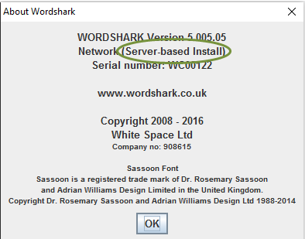Example (taken from Wordshark 5, a *Server-based* Install):

If already running “client-based”, please check that the clients, server and infrastructure are up to the required specification, and an anti-virus “Scan on demand” or other background program is not causing an overload.

If you are investigating slow running on a Server-based install, try moving one client machine from a Server-based install to a Client-based install as described at Stage 3. Because there may be registry entries involved, please follow the following routine IF the program is showing in “Programs and Features”:

1. Uninstall the S-Client from the client machine (if present).
2. Install the C-Client onto the client machines.

**LOAD BALANCING**

This is permitted under the terms of our Licence Agreement:

* You may load-balance the executable and program resources by having multiple copies of *wordshark- programs* and *wordshark-public* on several (application) servers and/or clients.
* You may locate the user data folder *wordshark-shared* on a different server to the *wordshark-program*s and

*wordshark-public.* **However, you may only have a single *wordshark-shared.***

If using a proprietary load-balancing solution, proceed according to its requirements for the executable and program resources (bullet point 1 above).

If a manual “load balancing” solution is preferred, then you may wish to proceed in either of the following ways:

* 1. Carry out a joint deployment: Install the S-Server MSI onto the server and then either of the following two MSIs onto the clients: Minimising the Client-based installs can speed initial deployment and (V5 only, any subsequent updating) whilst reducing infrastructure loading.
     1. Install the S-Client MSI for “*Server-based*” installation on wired clients that are unlikely to run Wordshark frequently or in great number, so are unlikely to overload the server.
     2. Install the *C-Client MSI* for *“Client-based”* installation on clients that are regularly used for Wordshark, & all wireless clients.
  2. Carry out a manual load-balancing by installing the program to run from multipleservers:
     1. Install the S-Server onto one server: This installs the Wordshark program data folders (*wordshark- programs* and *wordshark-public*) and a user data folder (*wordshark-shared)*.
     2. Use the network management MSI to install the SERVICE and MANAGER onto this server (though it is possible to install the MANAGER onto a separate, connected computer).
     3. Copy the program data folders (see point a) to shares of one or more other servers which are accessible by the clients. You may do this manually or by scripts.
     4. Deploy shortcuts to the clients. This can be done manually, by the provided S-Client MSI, by scripts or 3rd party tools.
        1. The ‘Target’ of the shortcut should point to the file ‘Wordshark5nrun.exe’ inside ‘wordshark-programs’ on the server that you wish to use for that client. Point a selection of client machines to each server according to its load-bearing ability.
        2. The ‘Start in’ of the shortcut should point to the path of the one ‘wordshark-shared’ folder in this installation (see point a).
     5. For further guidance on shortcuts see Appendix F

**USE OF SAMB****A/LINUX SERVERS**

Our Network Products v4.10 and v5 require a Windows Server, capable of running Windows Services. Client computers must run Windows OS.

It is theoretically possible for the user data folder, *wordshark-shared* to be hosted on a SAMBA / LINUX server, acting as a file server, subject to this folder and its contents being allowed read /write / modify / delete permissions for all groups of users accessing the program. [Contact](#supportcontact) Support for advice.

**VPN, Remote Desktops and virtualising to iPads, Macs, Android devices**

Version 5 runs happily on a windows Server 2012R2 (or later), from there being virtualised out to remote devices, (be these Macbooks, iPads, Android, Windows machines or otherwise) via VPN/Citrix/Remote Desktop etc.

**Proviso:** We assume your network has the robust and high-specification infrastructure and your technical team have the tech knowledge. *One thing to watch out for: To ensure sound works, check that the Windows Audio Service on the server is enabled and running. This is by default “stopped” on most networks.*

Our EULA also permits remote desktop access from home devices if your own network infrastructure/ permissions/broadband capability/policies allow this.

Technically, each instance of Wordshark or Numbershark uses around 400 Mb RAM, and the server requires the features and services that allow creation of a virtual soundcard. If serving more than around 10 virtualised devices we would suggest running from multiple servers or a multiple-core server. In all cases a SINGLE server hosts the data folder.

The data folder and manger have a low footprint, but the Manager must be located on a Windows server able to run a service and related White Space Network Manager to hand out the concurrent user tokens. It is always very much easier if you can co-locate the data folder, Service and Manager on the same Windows server, even if other servers are used to host and run the program itself.

Navigate to: Contents Instructions Stage 1 Stage 2 Stage 3 Stage 4 Trouble-shooting Contact

# Appendix D: Adding Additional Concurrent User Licences

You have a *site network licence* allowing deployment to all machines on the network. The *service and manager* ensure the licensed number of concurrent computer users is not exceeded. Administrators can check who is logged on, and on what machine, at “Users / List of users”. Within either the *numbershark- shared* folder (or *wordshark-shared* if there is no Numbershark installed)the “InstanceInfo” subfolder contains a file showing “maximum users”

If more concurrent users are needed, Sales can provide a new licence key (with the latest instructions) to unlock further users. The new licence key needs to be activated via the “Manager” program, by a tech with rights to access this program.

For prices, including upgrading and purchasing additional licences, contact:

020 8748 5927 Outside the UK: (+44) 208 748 5927 [sales@wordshark.co.uk](mailto:sales@wordshark.co.uk) [www.wordshark.co.uk](http://www.wordshark.co.uk/)

# Appendix E: Peer to Peer Windows Networks

This is permitted and possible: Proceed as for the Stages 1-4, designating one client to act as a “server” which MUST ALWAYS be switched on (with the White Space Network Service running) before other clients run the program. Deploy the full C-client MSI out to every machine at “Stage 3”.

Note that Microsoft limits “Home” OS licences to very few concurrently connected machines, and “Pro” OS licences to not many more (approx.10). Note the warning about clock times.

# 

# Appendix F: Creating and Deploying Shortcuts

If your network environment has a shared desktop (for example a redirected desktop or managed as a part of a network management suite) you can create the shortcut manually in the shared desktop location. A “Group Policy” rollout of the desktop icon to every machine is normally an easy way to deploy the desktop icons.

It is not possible to run the program from the executable “wordshark5nrun.exe. You NEED a shortcut, allowing the “Start-in” path to specify the data location, *wordshark-shared”.*

**Manually creating desktop shortcuts**

1. Right click the “*Wordshark5nrun.exe*” in the “*wordshark-programs*” folder and select “Create Shortcut”.
2. Right-click the shortcut and select “Properties”.
3. Set the *Start in* as the UNC path to the “*wordshark-shared”* folder on the server, NOT the default “*wordshark-programs”* folder.

Alternatively, if your network does NOT have a shared desktop system, included in the download is the “*Wordshark 5 Network S-Client.msi*”. Launch this MSI and follow the on-screen instructions, ensuring that you use a UNC path (with no $ if using Server 2008) when giving locations of the *wordshark-programs* and *wordshark-shared* folders, to place a shortcut on the “*All Users*” desktop. You can also automate the deployment of the shortcut using the “*Wordshark 5 Network S- Client.msi*”. This is covered in Appendix J

Navigate to: Contents Instructions Stage 1 Stage 2 Stage 3 Stage 4 Trouble-shooting Contact

# Appendix G: System Requirements

**Overview:**

These programs are primarily designed to run on a conventional Windows server network with Windows client machines.  Other configurations are possible and covered below and/or elsewhere in this manual.

**Network:**

* A server *service*and related *manager*utility form part of the program. In practice, we have found the programs also normally work well if the server / server farm is off-site (e.g. a server farm serving several schools within one organisation), and “multiple schools sharing one server” is a supported scenario discussed further in our full network installation instructions.
* A peer to peer (P2P) Windows 10 network is possible, running one of the clients as a “server” though Microsoft limit the number of concurrent connections in this scenario. P2P is discussed further in our full network installation instructions.  Linux servers will not work as they are unable to run the service.
* Active Directory network deployment is preferred, though not required*.  If AD is not possible, note that internal clocks for the server and clients need to be synchronised to within 10 minutes.*
* The program runs well on **interactive white-boards**or **secondary display monitors:**You may MOVE the Wordshark window to a secondary display after launch. By default, it opens maximised onto the primary display. Sign on as an Admin or Teacher user / Admin / Advanced / Resize window, and follow the on-screen instructions.

**Clients:**

* Windows 10, 32/64-bit Note that Win RT and Win 10 S mode are NOT compatible. Win10 (Education) may or may not work, depending on the security parameters selected, and we advise a “Trial” for schools running Win10 Edu.
* Mac computers and Chromebooks are NOT compatible: See “Non-Windows” section below.
* 2GHz minimum CPU, 2Gb RAM, 1.5Gb for client deployment(recommended). Running in “Terminal service” mode from a server farm requires minimal hard disk space but needs high-spec servers/infrastructure – see deployment options in “Stage 3” and Appendix J.
* Working soundcard & driver with speakers or headset connected
* Wordshark only: Microphone (required for some games and for creating recordings for own word lists in Wordshark)
* Display resolution: 1024 x 768 or higher
* Windows 7, 8 &10 touch screens are also supported. Larger touch-screens (11+ inches) normally provide a better experience than smaller screens.
* Whilst Server 2008 is now obsolete and not supported, it is likely to work. This is included in our full network installation instructions.

**Server:** Please read Appendix E if you have a Windows Pro peer to peer network (no server) or a NAS that does not allow services

* MS Windows Server 2012/R2, 2016, 2019 or later
* 2GHz minimum CPU
* 250Mb of RAM per user (if running terminal services mode). Minimal RAM is used in the recommended “client-deployment” mode, with around 99% of work carried out by client machines.
* 2Gb free hard disk space plus similar for a backup of the media if wished. . This can be reduced post-install to well under 1 Gb. This is discussed in Appendix P
* Display resolution: 1024 x 768 or better
* .NET Framework 4.7.2 (or .NET 3.5 for older servers) is mandatory on the server(s) hosting the service and manager. You do not require .NET Framework on other servers being used for load balancing/running a Server-based install or hosting the data –shared folder.

Server users may need to install / update / enable the .NET Framework 4.7.2 (or 3.5 for older servers) feature before starting installation. For more instructions on installing windows features please see <http://technet.microsoft.com/en-us/library/hh831809.aspx>

**Server 2008** is now obsolete and not supported. However, it is likely to work, but you may need to enable the Microsoft .NET 3.5 Framework from within the Features section of Server Manager. Further notes about this Rarely, you may first need to download and install .NET Framework 3.5 from the Microsoft download site <https://www.microsoft.com/en-gb/download/default.aspx> If this results in a message of “You must use the Role Management Tool to install or configure Microsoft .NET Framework 3.5.” this means that it is already present and you just need to enable it.

**Running Remotely via Citrix / VPN:**

Our licence permits running of our Windows Network products from a suitably powerful Windows Server via RDP/Citrix (remote desktop working) to off-site Windows and Mac computers and to non-windows devices such as iPads & Chromebooks. Allow around 400 Mb RAM for each instance of Wordshark or Numbershark. The server requires the features and services that allow creation of a virtual soundcard. If serving more than around 10 virtualised devices we suggest running the program files from multiple servers and/or multiple-core servers.  A SINGLE Windows server hosts the data folder for each program, and Stage 1 of the instructions gives the sharing and security permissions required for these folders.

**Networks with non-Windows Servers or Clients:**

We have a separate browser-based “Wordshark Online” product that works for a wider range of client devices, including Mac, iPads, Chromebooks and  Windows:   <https://wolhelp.wordshark.co.uk/portal/en/kb/articles/wordshark-o>

* We have stand-alone Wordshark and Numbershark products that work for Mac (not yet for Chromebooks)
* You MAY use the software on hybrid networks that include a mixture of Windows & Mac OSX clients PROVIDE you deploy the program exclusively to Windows clients and Windows Server(s): If deployed to OSX clients, file-sharing violations and other issues will occur.
* The network products do not work with Linux server networks. However, provided the SERVICE and MANAGER are hosted on a Windows machine, the program data folder *wordshark-shared* may be hosted on a SAMBA/LINUX server or NAS box. See “Special Situations” for details.
* Please read Appendix E if you have a Windows Pro peer to peer network (no server, with or without a NAS [network attached storage])

Navigate to: Contents Instructions Stage 1 Stage 2 Stage 3 Stage 4 Trouble-shooting Contact

# Appendix H: Sharing and hiding Folders & Setting Permissions

The following permissions must be set on the folders. Where “**all users**” or “**Everyone”** is shown, this may be read as **“Appropriate security groups of users”**

**HIDING folders:**

**Hiding the wordshark-shared folder (S2012 and later):**

If wishing to hide the folder, ensure the SHARE NAME is hidden with a $.

**Hiding the wordshark-shared folder (S2008):**

If using Server 2008, do not add a $ to the name of the folder, or include a $ in the path, or the deployment will fail. Hidden paths e.g. \\server1\app$\WhiteSpaceLtd\Wordshark5\wordshark-shared containing a **$ will normally fail on Server 2008** if used within our shortcut addresses. Instead, share the folder *wordshark-shared*, allowing the shortcut path to NOT contain a $, e.g. \\server1\wordshark-shared

Access-based enumeration will work, and this article may be useful:

<http://blogs.technet.com/b/aralves/archive/2007/09/20/windows-server-2008-access-based-enumeration.aspx>

**SHARING folders:**

Note that the folder name ***wordshark-shared* is case sensitive. It must be fully “lower case”.**

**Sharing folders on Windows Server 2008 / 2008R2 / 2012 / 2012R2 / 2016 & later**

* + 1. While logged on to the server as a domain (network) administrator, browse to the *Wordshark 5 network* folder that you need to share. This contains *wordshark-programs* and *wordshark-public* and ALSO normally contains the *wordshark-shared*” user data folder.
    2. Right-click the *wordshark-shared* folder and click “Properties”.
    3. On the “Sharing” tab click “Advanced sharing”.
    4. Check the “Share this folder” box.
    5. Set security and permissions:

1. Click “Permissions”.
2. For the “Everyone” group, check “Allow” for “Full Control”.
3. Click “OK” twice.
4. Make a note of the network path (UNC path) from the sharing tab.
5. Click the “Security” tab to set file permissions.
6. Click the “Edit” button.
7. Assign permissions for the relevant groups of users as described in section C.
8. Click “OK” twice.

**Inherited Permissions:**

Please check for inherited permissions: These may over-ride other permissions you may set, leading to issues if they are too restrictive. Depending on your network configuration, you may need to specify a special permission to allow users to delete, if this is not already granted. If assigning special permissions, tick the check box to “apply these permissions to objects and/or containers”.

Navigate to: Contents Instructions Stage 1 Stage 2 Stage 3 Stage 4 Trouble-shooting Contact

# Appendix I: Upgrading / Updating / Migrating or Rebuilding Servers

Different procedures apply for different releases and products. Please select your previous product from the following:

**UPDATING YOUR CURRENT V5 NETWORKS:**

* + Version 5 Networks prior to current release (Including update & reinstall due to Server Migration)

**UPGRADING FROM OLDER v3 OR v4 NETWORKS:**

* + Version 4.10 Networks
  + Version 3.06 to 4.09 Networks
  + Version 3.01 to 3.05
  + Version 1, Version 2: Data from all v1 and v2 networks cannot be migrated.

**UPGRADING FROM ONE OR MORE SINGLE USER PRODUCTS:**

* + Version 5 DVDs, USBs and single User Activated Licences
  + Version 3.00 to 4.08 CDs, USBs, Single User Activated Licences and Early Networks installed as

standalone installations

* + Version 1, Version 2: Data from v1 and v2 cannot be migrated.

Navigate to: Contents Instructions Stage 1 Stage 2 Stage 3 Stage 4 Trouble-shooting Contact

**Updating from** **older Version 5 Networks to latest release**

***Particularly recommended when reinstalling due to server migration/rebuild***

Organisations with a valid full licence for a Version 5 network are entitled to free of charge updates to the latest v5 release. You may check for program updates as the Program Administrator (NOT as a Teacher or Student user) from within the program under the menu Help / Check for Updates.

* The network licence will have been activated to a single specific instance of the wordshark-shared folder on a specific server
* If you wish to **move the folder, rename or rebuild the host server, or migrate to a new server, you MUST first deactivate the licence.**
* ***What to do if you have omitted this step***
* **Failure to deactivate may result in loss of the licence or a charge for a replacement licence.**
* You may reactivate your licence to a new location up to five years from initial purchase. Reactivation *may* not be available more than five years after initial purchase.

**Updating** An update is recommended for the following situations:

1. During the lifetime of this version, **free updates to the *service* and/or *manager***are occasionally issued, providing additional useful diagnostics if you experience an error. See Appendix L. This is quick, as you can install on top of the existing earlier White Space Network Management *service* & *manager,* and normally do not need a server restart unless one is already pending*.*
2. During the lifetime of this version, **free** **program updates** will also be issued periodically to further improve the program, and repair issues reported to us. If any “program related” issues are reported to you, please email us: We will tell you if the issue has already been subject to an update, or alert you when an update is available, and advise on the most efficient way of updating files for your situation should this be necessary. The links to the self-extracting MSIs are included in Stage 1
   * If you originally installed “Client based” at Stage 3, and have your original deployment file, you will need to over-write the old c-client MSI *and* c-client program files (containing the folders -public and -programs) with the new files, then re-deploy. ***Warning:*** *If you update any client machine, the server will detect this, and will allow the program to open on other client machines ONLY once these are also updated.*
   * If you originally installed “Server based” at Stage 3, uninstall the s-server MSI from the server, and install the new s-server MSI, taking care to retain exactly the same (already shared)*wordshark-shared* data folder.
3. If migrating to a new server, do not attempt to “copy” the old install. Instead, update by carrying out a fresh install using the following instructions:

**Migrating**

1. **Attempting to migrate by moving files across will not work:** The program requires registry entries created by the install process.
2. **If you are migrating to new servers and/or new clients**, it makes sense at this point to install the latest v5 files. You **must** first deactivate the licence (via the Service and Manager) which is tied to the OLD server wordshark-shared folder location. ***What to do if you have omitted this step***

* If your new server will be able to obtain data from the old one, note that mid-install (stage 1 of instructions) you will be given an option to browse and import data from the OLD *wordshark-shared*. The program will import required user data and settings and leave behind files that are now obsolete.
* If your new server will NOT be able to connect to the old one, we advise that you *copy* the old data folder *wordshark-shared* to your new server, retaining the folder name but placing it inside a folder, e.g. “OLD Wordshark data” to help avoid confusion. Please do not attempt to use the old *wordshark-shared* folder on the new server, as this will contain obsolete files based on the old server’s details.

1. Follow Stages 1 – 4 described above, and note that early in the S-Server MSI wizard you will be asked to locate the OLD *wordshark-shared* folder so that the program MSI can import the relevant files into the new *wordshark-shared* folder.

Navigate to: Contents Instructions Stage 1 Stage 2 Stage 3 Stage 4 Trouble-shooting Contact

**Upgrading from Version 4.10 Network to Version 5**

**Where the v4 user data folder *wordshark-shared* is on the same server as the intended new v5 install:**

**IMPORTANT: DO NOT deactivate or UNINSTALL v4.10 from the server.**

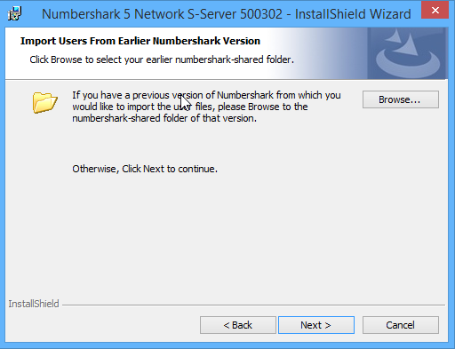Install version 5, as outlined in the full installation instructions (Stage 1 onwards). NOTE that during Stage 1 installation of the *Wordshark 5 Network S-Server.msi*” you are given the option to browse to your v4 user data folder. To do this, import the user files from the earlier version into the new version by browsing to the existing *word-shared* or *numbershark-shared* (as appropriate) folder when prompted during the installation:

Complete the installation by following the full installation instructions.

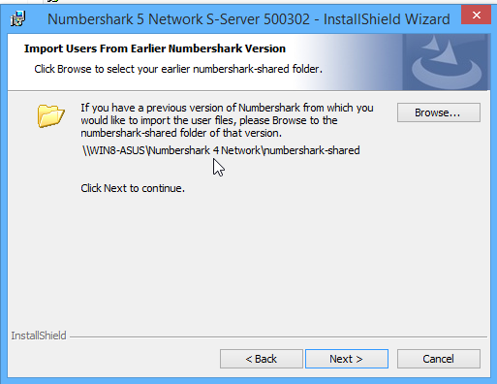There is no need to reinstall the Service and Manager (Stage 2) ***unless*** your current installation shows an earlier version to the current release. The Manager release will be shown in the Manager title bar. The Service release will be shown under the ‘service details’ tab in Manager if version 1.0.4.0 or later. Alternatively, it can be found in “Control Panel” under “Programs”. You will NEED v1.0.4.0 or later.

Test that the program is working for Administrator, teacher and pupil accounts. Once satisfied that the program is working uninstall the previous version. v4.10 was installed via an MSI so will need to be uninstalled via Control Panel.

Navigate to: Contents Instructions Stage 1 Stage 2 Stage 3 Stage 4 Trouble-shooting Contact

Once installed the Manager will show the old installation status as ‘change’ with the new installation needing to ‘Activate’:

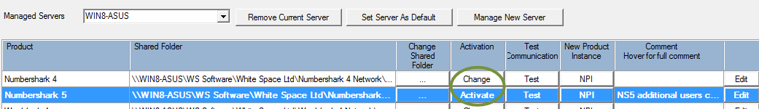

Click on the ‘Activate’ button for version 5.

Check that ‘Activate’ has been selected on the ‘Product Activation’ window:

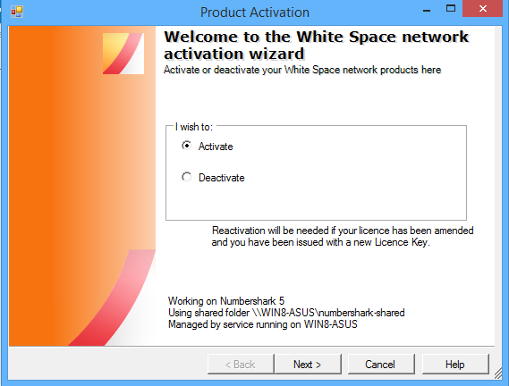

Click ‘Next’ and enter the new licence details:

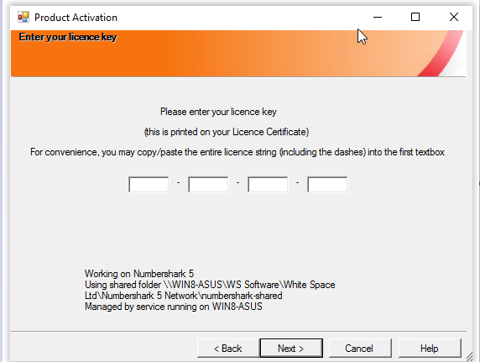

Navigate to: Contents Instructions Stage 1 Stage 2 Stage 3 Stage 4 Trouble-shooting Contact

Click ‘Next’. You will be prompted that this is an upgrade licence, an earlier licence has been found and will be deactivated

: 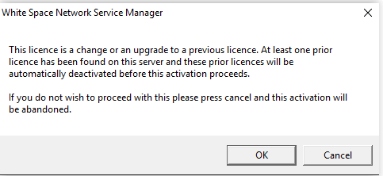

Click on ‘OK’ to complete activation:

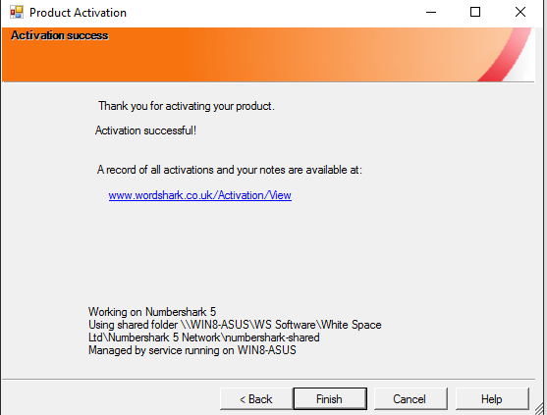

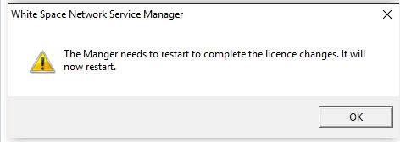Click Finish to return to the Manager:

* + Version 5 will be activated and the status will now show as ‘Change’
  + Version 4 will be deactivated and the status will now show as ‘Activate’

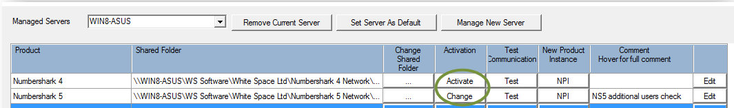

Uninstall v4.10 from the server via Control Panel. Remember to uninstall the program from the client machines where this is a client based installation or to remove any desktop icons where server based.

Navigate to: Contents Instructions Stage 1 Stage 2 Stage 3 Stage 4 Trouble-shooting Contact

**Upgrading from Version 3.06 to 4.09 Networks**



**Upgrading to v5 from v3.06 to v4.09, where the user data folder *wordshark-shared* is on the server**

Do **NOT** remove/uninstall the earlier version.

Install version 5, as outlined in the full installation instructions.

To import the user files from the earlier version into the new version browse to the existing word-shared folder when prompted during the installation:



Complete the installation (including installation of the Service and Manager and activation of the program) by following the full installation instructions.

Navigate to: Contents Instructions Stage 1 Stage 2 Stage 3 Stage 4 Trouble-shooting Contact

**Upgrading from Version 3.00 - 3.04 Networks to Version 5**

**The old Wordshark data will normally be in a server folder *shark-shared* and old Numbershark data will normally be in a server folder *nshark-shared***

**Wordshark only:**

**v3.03** or earlier any “own courses” will be saved in the *shark-public* folder as “**publictopics2**”, “**publictopics3**” etc. If present, these will need to be manually copied from *shark-public* of the old program into the *wordshark- shared* (**NOT** public) of the v5 program.then RENAMED to “**extracourses2**”, “**extracourses3**” etc.

Do **NOT** remove/uninstall the earlier version.

Install version 5, as outlined in the full installation instructions.

To import the user files from the earlier version into the new version browse to the existing word-shared folder when prompted during the installation:





Complete the installation (including installation of the Service and Manager and activation of the program) by following the full installation instructions.

Test that the program is working for Administrator, teacher and pupil accounts. Once satisfied that the program is working uninstall the previous version. For v3.00 to v3.04 this is normally a case of deleting files.

Navigate to: Contents Instructions Stage 1 Stage 2 Stage 3 Stage 4 Trouble-shooting Contact

**Upgrading from Version 5 DVDs, USBs and single User Activated Licences prior to current Network 5 release**

The default location of the user data folder *wordshark-shared* will be:

C:\ProgramData\White Space Ltd\Wordshark 5 DVD C:\ProgramData\White Space Ltd\Wordshark 5 Stand-alone

For the USB this will be located on the *WS-SHARED* partition of the USB. Also check the contents of the folders within *wordshark-shared*:

* + Keypads – own keypads
  + Records – user records
  + Resources – sounds and images created for users own word lists
  + Universal – for universal options; e.g. fonts, automatic sign on, enforced set work

**If you ae upgrading from a single user activated licence:** delete the SA83FB.xml file from within the wordshark- shared / numbershark-shared folder.

If upgrading from multiple older single user licences, it is not possible to retain files with identical names (e.g. teacher.sha) from different machines. You will need to decide which instances to import into v5.

Do **NOT** remove/uninstall the earlier version.

Install version 5, as outlined in the full installation instructions.

To import the user files from the earlier version into the new version browse to the existing word-shared folder when prompted during the installation:



Complete the installation (including installation of the Service and Manager and activation of the program) by following the full installation instructions.

Test that the program is working for Administrator, teacher and pupil accounts. Once satisfied that the program is working uninstall the previous version. NOTE that you do NOT have to uninstall the USB product from the USB stick.

Navigate to: Contents Instructions Stage 1 Stage 2 Stage 3 Stage 4 Trouble-shooting Contact

**Upgrading from Version 3.05 to 4.08 (DVDs, USBs, Single User Activated Licences and Networks installed as standalone installations)**

* + The Stand Alone (single user activation) licence is normally for multiple machines, so you may have several clients to retrieve data from.
  + The CD licence allows the program to be installed onto multiple computers (even if the school has only a single CD), so the same applies.

In either case, you need to retrieve the data from every machine that had the older program installed on it. It is not possible to have duplicate user files so if the same usernames occur in more than one *wordshark-shared* folder, the school will need to decide which files to keep.

If an administrator has created their own courses these will also be in the *wordshark-shared* folder as ‘extracourses’. These will also be needed, if present.

For each machine: **back up the folder containing your user files.**

User files are stored in the folder *wordshark-shared*. For older versions of v3 they will be in a folder called *shark- shared*. If installed using the default installation the folder will be located on the client machines in one of the following locations:

C:\Documents and Settings\All users\Application data C:\Program Files

C:\Program Files\Wordshark

C:\Program Files\White Space Ltd\Wordshark

For 64 bit machines the path will be “Program Files(x86)”

For versions 3.00 to 3.03 any “own courses” will have been saved in the

*shark-public* folder **as ‘publictopics2’, ‘publictopics3’** etc. It is not possible to have duplicate filenames, if identically named “own courses” have been created on more than one machine the school will need to decide which files to keep.

On each machine: **Uninstall the old version** via control panel/ Add & Remove Programs (from every machine) to remove the program and related registry entries, then manually remove the *wordshark-shared* (which is not removed via an “uninstall”). When backing up and uninstalling is complete on every machine, clean the data.

**Clean the Data:**

1. Make a copy of your backed-up data, and clean it ready for re-use by removing surplus files:
   1. Delete all **.LOCK** files
   2. Delete all .**sht** files
   3. Delete all **HS_ERR_PID** files.
   4. Delete the file **options.sha**
2. DO NOT delete any users who have now left or are otherwise no longer required: Deletions must only be carried out after importing and checking files is completed, otherwise work given to students by an administrator who has been deleted will not be able to be removed.

**Install the v5 program,** including installation of the Service and Manager and activation of the program, using the full installation instructions. On first launch of the program you will be asked to enter a username. **Enter a username that is NOT in your backed up data** and click OK. Say ‘yes’ to becoming and administrator and give yourself a password. Close the program before restoring the data.

**Restore and Test the Data:**

* 1. Place a copy of your cleaned data into your *wordshark-shared* folder
  2. Rename publictopics2 (etc. if several) to “extracourses2”, “extracourses3” etc. and add into the new

*wordshark-shared* folder NOT into *wordshark-public*

* 1. Reload the program and complete the normal testing as per Stage 4
  2. Test the restored files by signing on once more as the program administrator. Go to Admin/Advanced feature /Check user files. This will check file integrity and advise you if any corrupted user files are reset to “new user”

Navigate to: Contents Instructions Stage 1 Stage 2 Stage 3 Stage 4 Trouble-shooting Contact

# Appendix J: Installing the Program onto Client Machines

On infrequently used wired clients, our programs may be launched via a desktop icon, the program itself hosted and run on the server (“Thin client mode”, or “Server Based Install”). This speeds deployment, at a cost of slower loading for end users & increased server use & network traffic. Methods of deploying a desktop icon are covered in **Appendix F.**

**For best experience, we recommend that client machines load our programs from their own local hard disks and run locally, accessing *only* the user data from the server [word][number]shark-shared folder.** This “Client based install” speeds loading and greatly reduces network traffic, so is normally the preferred deployment.

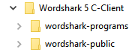

***What is involved?***

The deployment involves moving copies of the **C-Client** program folders, (which contain **[word][number]shark-programs** and **[word][number] shark-public** folders) from the server “Source Files” folder you created at Stage 1, to the c:/program files [ x86] on each local machine, and creating a desktop icon that points the “Target” to the client c:/program files [x86]/wordshark-programs/wordshark5nrun.exe with the “Start – in” pointing to the UNC path to the **server [word][number]shark-shared folder, e.g. *//servername/wordshark-shared***

***What do I need to do?***

You may deploy

* using your own in-house method/GPOs,
* or via a **manual** install (end of next page), or
* via a fully automated silent install using our own Config file as described below
* Or via a command line
* Or via SCCM (Appendix N)

*Notes for users of Microsoft Intune*

Trouble-shooting Deployment Issues

**Fully automated silent deployment using the White Space Config file:**

Included with the install MSI is support for silent and automated deployment. With this, the MSI can be deployed to workstations via Microsoft SCCM (see Appendix N) and Group Policy. Other 3rd party network management tools may be used to deploy to the software to your workstations.

*White Space Support is unable to advise or support your network and/or software management tools: Refer to your documentation or support personnel for these tools for further advice.*

To perform a silent or automated deployment proceed as follows. *(see overleaf if you need support for troubleshooting silent deployment issues)*

1. 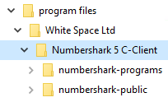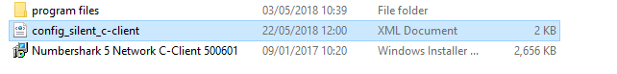Ensure the 3 downloaded components on the screenshot below are all saved into the root of the ***same*** folder (*wordshark source files* if you have followed the instructions at stage 1). Ensure this folder is **shared**. Silent deployment *may* fail if the NTFS/Folder security tab settings do not include “Everyone”. Note that the “program files” include the *wordshark-public* and *wordshark-programs* folders

Navigate to: Contents Instructions Stage 1 Stage 2 Stage 3 Stage 4 Trouble-shooting Contact

1. At the “ENTER INSTALL PATH HERE” field in the *config_silent.xml* file, the default location for the folders *wordshark-programs* and *wordshark-public w*ill normally be *C:\Program Files (86)\White Space Ltd\Wordshark 5 c-client* (the MSI also detects and adjusts for 32 bit clients).

If you wish to change this, edit the *config_silent.xml* file to set your install directory to your preferred location. (Notepad works best for this).

1. At the “ENTER DATABASEDIR PATH HERE” enter the UNC path to the *wordshark-shared* or *Numbershark-shared* folder (as appropriate) on the server.
2. Deploy the MSI to target machines using your network management software or via a command line/batch file.

The config file, with example entry added, looks like the text box below. In this example:

* The desired location for the program on the client machines is the default location'C:\Program Files (x86)\White Space Ltd\wordshark 5 C-Client' so the “ENTER INSTALL PATH HERE” has not been touched.
* the server path to the wordshark-shared folder is *\\APPSERVER\wordshark-shared*identical to that displayed on the White Space Network Manager
* Note that for most deployments, this is the only modification needed for the config file (other than then saving it back into the wordshark source files folder as a .XML file!)

<?xml version="1.0" encoding="UTF-8"?>

<!--

This XML file is to be used with C-Client msis only, for silent installations as an

alternative to supplying command line INSTALLDIR and DATABASEDIR parameters.

The C-Client msi will only detect this xml file if both files are located in the same folder.

If the value in the INSTALLDIR element is left unaltered, the programs files will be installed

to the default directory ('C:\Program Files (x86)\White Space Ltd\wordshark 5 C-Client').

The value in the DATABASEDIR element must be specified for a successful installation.

-->

<data version="1.0">

<config>

<!--

Edit the text in the <INSTALLDIR> element below (in place of the text 'ENTER INSTALL PATH HERE')

to set your chosen installation path.

- The text should be the local path into which you want to install the wordshark program data folders.

- The path does not need to already exist on the file system. The installer will attempt to create required folders.

-->

<INSTALLDIR>ENTER INSTALL PATH HERE

</INSTALLDIR>

<!--

Edit the text in the <DATABASEDIR> element below (in place of the text 'ENTER SHARED PATH HERE')

to set the path to the server wordshark-shared folder.

- The text should be the UNC path of the wordshark-shared folder on the server

- This path should be a folder which already exists on the file system

-->

<DATABASEDIR>*\\APPSERVER\wordshark-shared*

</DATABASEDIR>

</config>

</data>

Navigate to: Contents Instructions Stage 1 Stage 2 Stage 3 Stage 4 Trouble-shooting Contact

**Troubleshooting Silent Deployment:** *See also* *troubleshooting appendix* *for error codes*

Ensure you are using the latest MSIs, (NOT the superseded ones on the original DVDs if you have these – the product was provided on DVDs for very early releases of v5)

Most deployment failures are caused by issues relating to browsing the network to locate the wordshark-shared folder and/or issues with sharing or permissions: A Windows error 1603 may be flagged up.

* Network discovery must be turned on.
* Ensure you are logged on with elevated privileges: If your logon account does not have permissions to install into the required location on the client machines, then the process will fail.
* Ensure the MSI, Config XML and program folders *wordshark-programs* and *wordshark-public* (and their contents) are in the “*wordshark source files*” shared folder, and the wordshark-shared folder is also correctly shared (“Everyone” “Full Control”), so that clients can see all required locations. In Stage 1, we recommended that you create a folder (e.g. “*wordshark source files*”) inside the *White Space Software* folder, and download the self- extracting MSI file(s), directly into this folder. *Moving the “wordshark source files” folder next to the “wordshark-shared” folder, resharing and using this server location for deployment has helped several schools.* Related failures have been traced to:
  + an issue with the msi locating the drive for the data folder
  + The MSI not “seeing” the *wordshark-shared* folder, due to incorrect permissions or path
  + the deployment folder is not in a shared directory
  + the deployment folder or databasedir path is hidden by a $ (this is a particular issue in S2008, rarely in later servers)
  + a space in the path to the msi or the wordshark-shared folder
  + Address paths to the MSI not being specified as UNC paths (they need to be)
  + Silent deployment *may* fail if the NTFS/Folder security tab settings do not include “Everyone”.
* Having edited the XML file, sending the MSI out with a silent switch (/qn) has occasionally failed.
* Ensure there is read/write permission to the All Users desktop to create the shortcut icon OR ELSE create the icon to other appropriate location:
  + The “Target” is the path and .exe file, so for a client-based install may be similar to: c:\program files (86)\White Space Ltd\Wordshark 5 C-Client\wordshark-programs\Wordshark5nrun.exe
  + The “Start-in” is the path to the user data folder on the server, *wordshark-shared*, e.g. *\\server4\apps\wordshark-shared* which is shown as the
  + NOTE that if on Server 2008, both must **not** have a $ in the path – see guidance on hidden shares
  + NOTE that if you have Ranger, Impero, or are using Microsoft File Screen Manager, your paths may well need to be added as exemptions.
* Adding quotation marks around the DATABASEDIR path when they are not needed can cause deployment to fail.
* Rarely, if the server is awaiting a reboot, deployment may fail. Try a reboot.
* On one occasion, failure was traced to a corrupted Main Administrator Account. Creating a new Admin account allows the MSI to proceed as expected.

**Manual Install:**

*Either:* Return to the Source Files folder / program files / White Space Ltd / and find the folder “Wordshark 5 C-Client”, containing wordshark-programs and wordshark-public: Copy this C-Client folder with its two sub-folders onto one or more memory sticks.

*Or: E*nsure that this folder is available on a server share to drag across to client computers. Copy (or drag from server) the ““Wordshark 5 C-Client” to the c:/program files (for 32 bit clients) or to c/program files (x86) if you have 64 bit clients.

On each computer, create a desktop icon –as follows, or see Appendix F for other options.

1. Right click the “*Wordshark5nrun.exe*” in the “*wordshark-programs*” folder and select “Send to desktop (Create Shortcut)”.
2. Right-click the shortcut and select “Properties”.
3. Delete the default “*wordshark-programs”* from the “Start in” field, and insert the path (UNC, and if on Server 2008 no $) to the “*wordshark-shared”* folder on the server (exactly as shown in the “*manager”* address*)*, and click “OK”.

Overleaf: Notes for users of Microsoft Intune / Using a Command Line

*Notes for users of* ***Microsoft Intune*** *from a technician who used this for client deployment:*

*“I used 7zSFX builder (a wrapper for 7Z) to package up the required files* and the shortcut to create a self-extracting file that ran a simple cmd file to copy the shortcut to the required directory once the extraction completes.  You then need to set Intune to install the Self Extractor as a required App for the target device.”*

*\*Create a folder “Wordshark5” and copy into it the 2 folders wordshark-programs and wordshark-public. Copy “Wordshark5” with its 2 subfolders out to every client, e.g to c: program files(x86).*

*Then add an icon to “desktop – all users”, target being the c: program files(x86\Wordshark5\wordshark-programs\wordshark5nrun.exe and the “start in” path being the UNC path to the server wordshark-shared data folder.*

**Install via Command Line:**

You may install via a Command Line switch, butNOTE that if you specify both a command line and our own XML file explained above, the command line will take precedence.

As with other deployments, our *program files* folder must be located in the same shared deployment folder as the *c-client MSI.* Trouble-shooting deployment

The general syntax is:

msiexec /i “[UNC path to the C-Client msi]” DATABASEDIR="\[UNC path to the wordshark-shared or numbershark-shared folder as appropriate]” /qn

Examples:

msiexec /i “\\server1\Deploy\Wordshark 5 Network C-Client.msi” DATABASEDIR="\\server1\Software\White Space Ltd \Wordshark 5\wordshark-shared" /qn

msiexec /i “Wordshark 5 Network C-Client.msi” DATABASEDIR=”\\servername\schoolshareddata\wordshark-shared” /qn

The two examples above install Wordshark’s program files to the default directory in Program Files.

However if you would prefer to install elsewhere please specify an INSTALLDIR parameter e.g.:

msiexec /i “Wordshark 5 Network C-Client.msi” INSTALLDIR="D:\Educational Software\Numbershark 5 Network" DATABASEDIR=”\\servername\schoolshareddata\wordshark-shared” /qn

Navigate to: Contents Instructions Stage 1 Stage 2 Stage 3 Stage 4 Trouble-shooting Contact

# Appendix K: Server farms hosting multiple schools’ Wordshark/Numbershark networks: “New Product Instances (NPI)”

**FAQ: The Service and Manager: Adding Further Instances of Wordshark or Numbershark** (Network versions v4.10 or v5) **onto a network**

**How do I run the “Wordshark 5 Network C-Server or S-Server” installer multiple times on the same server to create the multiple “wordshark-shared” folders so that they all appear in the White Space Network Manager?**

*This appendix is applicable if you are installing into a “large infrastructure/multiple schools” situation, e.g. multi-school group, council or state-wide server farm or similar situations where several instances of either program will be located within the same server / server farm.*

This Appendix explains how to install multiple instances of the same White Space network product in a network. It is assumed that the network is already running at least one instance of Wordshark and/or Numbershark, and the licences required to activate the additional instances for other schools have been purchased.

**Do not** run the server MSIs to install additional licences. **Instead**, use the “New Product Instance” (NPI) facility provided in the White Space Network Manager: After the first instance of each program, i.e. to add a 2nd and subsequent schools/campuses, you have multiple options:

**Option 1 Overview**: Locate the data folders for all of the campuses/schools onto the same, single, computer. Deploy the “C-Client MSI” to the hard disk of every client machine. *This distributes most of the load to local hard drives, and minimises bandwidth, so is normally the preferred option.* *Details*

**Option 2 Overview:** Put the data folder **and programs** for all of the campuses/schools onto the same, single, computer*: When you come to update the programs you only need to update one location, BUT the one server is serving many sites, with possible overload. This needs a VERY powerful server and uses significant bandwidth.* *Details*

**Option 3 Overview**: Put a copy of the programs onto different application servers, and just put the data shared folder for all of the schools on a single “data” server (e.g. for ease of backing up). *The programs will be using the processing resources on separate application servers. This is a variation of Option 2, but sharing the load of running the programs across several servers, and a “Service and manager” on the “Data” server only. This is commonly seen in “Thin client” situations.* *Details*

**Other Options:** We have worked hard to ensure that our programs can be installed onto a wide range of Windows-based infrastructures, beyond the three described above. For example, installation Option 1 could be adapted to install a single “test” data folder onto a server, with subsequent “live” data folders each hosted on a different server or NAS. The “service” and “manager” based on that first server would then control the multiple instances elsewhere within the server farm. Please contact Support for advice if you have a situation different to the options already listed.

**Option 1 Details**: For the FIRST INSTANCE ONLY of each program, follow Stage 1 instructions to install the S- Server ONLY. Thereafter, at Stage 1 of the instructions, DO NOT run the C-Server MSI or the S-Server MSI. Instead, follow the steps for Option 2 below. Return to the main instructions Stage 3, and deploy the C-Client MSI out to each client machine in the given school(s), then proceed to Stage 4.

**Option 2 Details:** For the FIRST INSTANCE ONLY of each program, follow the main instructions Stage 1 to run the S-Server MSI & create the first instance of a school –shared folder. HOWEVER, we advise that you direct the S-Server to create the “Program files” (wordshark-programs and wordshark-public folders) into a location that can be accessed by ALL schools. *(Continued below)*

1. For each school, create a separate user data folder *wordshark-shared*. Each needs to be a UNC path, with no spaces: for example

\\myserver\Data\WhiteSpaceProducts\St_Marys_School\wordshark-shared

\\myserver\Data\WhiteSpaceProducts\St_Marys_School\numbershark-shared

\\myserver\Data\WhiteSpaceProducts\Johns_Academy\wordshark-shared

1. Share each folder with share permissions of ‘Full control’ for ‘Everyone’ (in the appropriate school).
2. All users for the given school must have read, write and modify access to their *wordshark-shared* folder.
3. Open (or “close then reopen”) the White Space Network Manager and locate the same product with the same major release (version 4 or version 5) as the one you wish to add. Click the NPI button. (see screenshot)

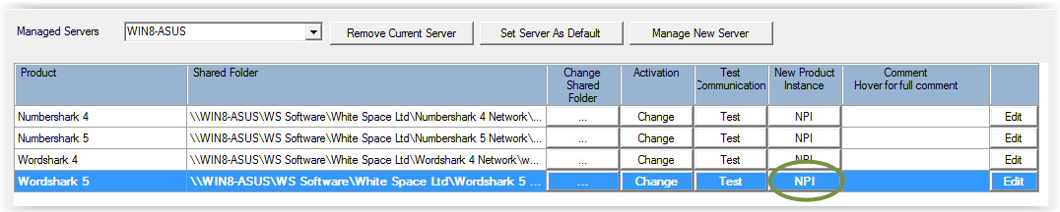

1. 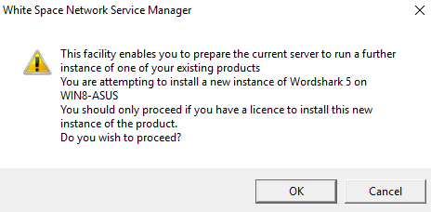A warning message will be given. Click OK to continue.
2. 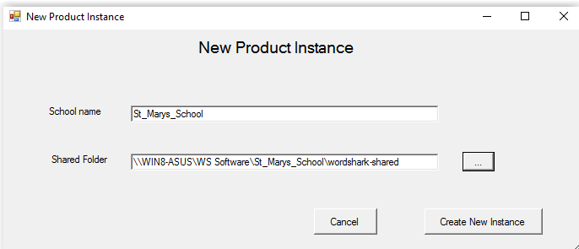Fill in the school name and the UNC path to the *wordshark-shared* folder you created at step 1.

NB: The school name must be unique. If your service needs to manage more than one school with the same name, extend the names (e.g. by including distinguishing location or postcode).

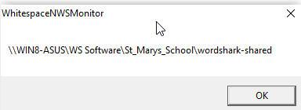

1. Click ‘Create New Instance’. A confirmation will appear. Click OK.
2. It may take a few seconds for the registry and manager changes to be made. You will then be prompted to restart Manager. Click OK to close and reopen the Manager.

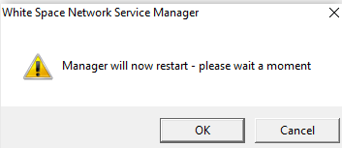

1. The new instance will now be registered in the White Space Network Manager.
2. Activate the newly registered instance of the program by clicking ‘Activate’ and entering the details as shown exactly on the Network Activation Licence (usually sent by email). You may find it useful to add a note in the “Comment” field: You may edit any comment field in the manager using the “Edit” button just to the right of this field.

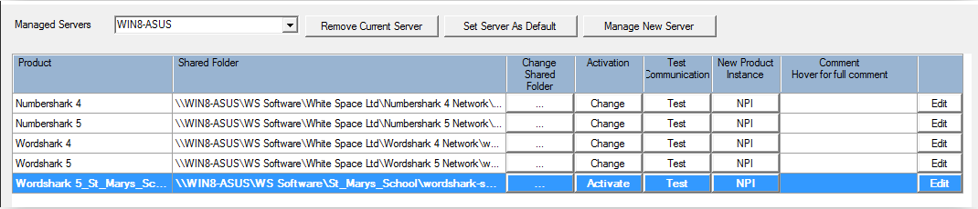

1. Once activated, follow the main installation instructions Stage 3 and Stage 4 to deploy or install the program desktop icon onto the client machines, setup and test.

**Option 3 Details:**

**On the DATA Server:** For the FIRST INSTANCE ONLY of each program, follow the main instructions Stage 1 to run the C-Server MSI & create the first instance of a school wordshark–shared and numbershark-shared folder.

Then follow “Option 2 Details” above from point 1 to create and activate the individual school data shares.

**On the APPLICATION Servers** On each server, run the C-Client MSI of each program ONCE to install the Program Files (containing the folders wordshark-programs and wordshark-public).

**On the SCHOOL CLIENTS**: Follow the main installation instructions Stage 3 and Stage 4 to deploy or install the program desktop icon onto the school client machines, setup and test.

Navigate to: Contents Instructions Stage 1 Stage 2 Stage 3 Stage 4 Trouble-shooting Contact

# Appendix L: Updating the Service and Manager

The *Service*, with its *Manager* interface, handles various diagnostics and fault-finding tasks, and controls the licencing for all instances of Wordshark and Numbershark activated network licences.

There may be several of each, if a server is shared between a cluster of schools: In this case, the “multiple install” process described in Appendix K is followed.

The ability of both components to fault-find and self-repair, and log more helpful diagnostics for support increases with each update. We therefore suggest that you download the latest *Service* and *Manager* at appropriate times. The Control Panel/Programs & Features on the server displays the current version of the “White Space Network Management” (i.e. both the *service* and *manager*).

[Download the latest Service & Manager MSI](http://www.wordshark.net/Downloads/NAManagement.aspx)

It is not necessary to uninstall the active *Service* and *Manager* unless you wish to change to a different port from the default, 9001, which is used *only* for internal communication between the *Service* and the *Manager*. Run the latest MSI, which will (if required) prompt you to agree to the installer closing the existing *Service* and *Manager* as it installs the new ones.

Navigate to: Contents Instructions Stage 1 Stage 2 Stage 3 Stage 4 Trouble-shooting Contact

# Appendix M: Template Email/letter for Installing Technician

If this page does not copy and paste into an email, it is available as a [separate document](http://www.wordsharksupport.co.uk/net500/Annex-M.docx) in “Word” .docx

From …………………………………………………. (Installing Technician)

To ……………………………………………………..

I confirm Wordshark 5/Numbershark 5 is/are now installed, the network licence(s) are activated, and the software has been tested on at least one client machine as a restricted (student) user.

**Important Post-Install Information for Network Manager and End Users**

1. The software has been rolled out on the following networked computers {FILL IN}.
2. There is no restriction on the total number of staff and student users that can access the program(s), but the licence limits to {fill in CONCURRANCY} users having access to the program at any one time.
3. As the lead member of staff for this program the essential initial steps you need to take to complete setup are listed in a separate document, the most recent edition being available from [support@wordshark.co.uk](mailto:support@wordshark.co.uk)
4. The following program administrator(s) have been set up

|  |  |  |
| --- | --- | --- |
| Technician* | Username  {FILL IN} | Password  ****** |
| Your user account | Username  {FILL IN} | Password  {FILL IN} |
|  |  |  |

*As technician*, I have also set myself as a program administrator, should staff report any difficulties. Any program administrator has the ability to sign in, go to ‘Admin /Add and manage students and staff’, click on any other administrator, teacher or pupil, and rename, change their password or delete them.*

# cid:image002.png@01D2CA53.17B91EB0Appendix N: SCCM Deployment

Several schools have deployed to clients via SCCM. Whilst this is not a deployment method we are able to offer support for, the following helpful tips were received from a school tech (Thank-you, Steve M!). Further SCCM suggestions are here:

<http://www.edugeek.net/forums/educational-software/183549-wordshark-sccm-deployment-not-working.html>

“The MSI will install via SCCM providing it is not set as hidden. For any other people who might have the same issue this is how I’ve got my deployment set in SCCM.”

Select User Experience tab and set 1) Installation behaviour to "Install for system" 2) Logon requirement "Only when a user is logged on" 3) Installation program visibility "Normal" (NOT “Hidden”) and tick "Allow users to view and interact with the program installation".

Using the /passive command line, after checking I have the correct settings in the XML config file.

The program will install if set as in the following screenshot. Using the passive command means the user will see a progress bar but won’t be able to cancel etc.

Navigate to: Contents Instructions Stage 1 Stage 2 Stage 3 Stage 4 Trouble-shooting Contact

I adjusted the detection method so that SCCM knows Wordshark was installed, by using the date of the 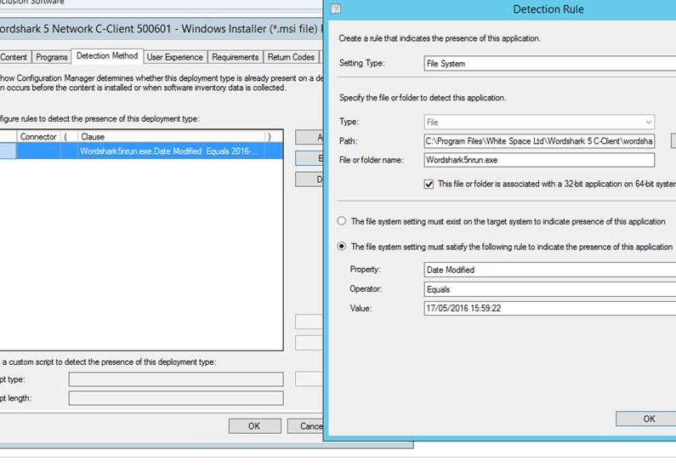wordshark5nrun.exe file. If updating in the future, this would need changing to the date of the later .exe file:



This allowed SCCM deployment to work.

We are grateful to Wayne for this alternative detection method:

DaveA kindly added to the body of knowledge: Our MSI installer checks that the *[word][number]shark-shared* folder is present. With SCCM, you need to ensure the computer account has permission to read the *-shared* folder. Just like a deployment share, Domain controllers need “read” permissions to browse to and read the *-shared* folder. Setting “Domain Computers – Read” on the whole application share sorted the problem in this case.

# Appendix O: GDPR Compliance for Version 5 Wordshark and Numbershark

For schools and organisations within the UK or EU, covered by the General Data Protection Regulation (GDPR), or the GDPR (UK), you may need the following information:

* The MSIs for our fresh downloads are hosted within the UK, but contain no school or personal data whatsoever.
* The programs themselves, which contain no school or personal data, are normally hosted on the client machines, but can be hosted on the school’s own server. Your server is normally on-site, but may be within your authority/organisation server farm wherever that is.
* The user data folder (wordshark-shared or numbershark-shared) is stored on your own server. This is normally on-site, but may be within your authority/organisation server farm wherever that is. You can check the exact share location, as this is the “Start-in” path of the desktop shortcut icon, and your school technician should be able to confirm this and say where any data backup is stored. We do not host v5 user data on our own servers.
* We may ask you to provide a zipped copy of the user data folder as this can often help us trace issues that cause errors/malfunctions or crashes. The Admin menu allows you to send a complete zip (including user names) or an anonymized zip depending on the strictness of your organisation’s policies. The data folder contents are scrutinized for clues to support resolution of the issue and efficient use of the program, and user data is not used other than for this purpose.
* We keep records of support queries, both to ensure efficient and effective responses to individual enquiries and to enable us to better understand technical and educational issues with our products.
* Our company general GDPR Privacy information is available at <http://www.wordshark.co.uk/privacy-statementAndGDPR.aspx> though note that much of this relates to our sister product “Wordshark OnLine” rather than to Wordshark / Numbershark v5 .

Navigate to: Contents Instructions Stage 1 Stage 2 Stage 3 Stage 4 Trouble-shooting Contact

# Appendix P: Reducing Server Disk Space Requirements

The two programs, along with the original self-extracting zip files, the extracted zip files, the program files, service, manager, and also include allowing for build-up of 1000 or so user files/ records / diagnostic logs for 2-3 years, can require around 8Gb of disk space (around 4.5 Gb for Wordshark and 3.5Gb for Numbershark).

*However:* You may download the latest zip files at any time, so you need retain neither the self-extracting .zip files, nor source files after installation. This saves around 4Gb of the total.

If server disk space is at a premium you can reduce a further 1Gb of program files: For each program, choose to run the C-Server MSI instead of the S-Server at Stage 1 point 8. This installs the -shared data folder on the server, but no program files. In this configuration, running the program from the server is not possible, and you MUST install the “Client-based” option at Stage 3, in which the program files are deployed to client hard drives.

You may also minimise the gradual growth of redundant user data: In this way, the fingerprint for both programs will normally be able to be maintained at under 1Gb for the two programs in most schools.

* Open the White Space Network Manager, go to the “Logs” tab, and limit logs to around 6 months or 51Mb, so that the log files do not keep growing (around 108Kb per day if both are installed).
* 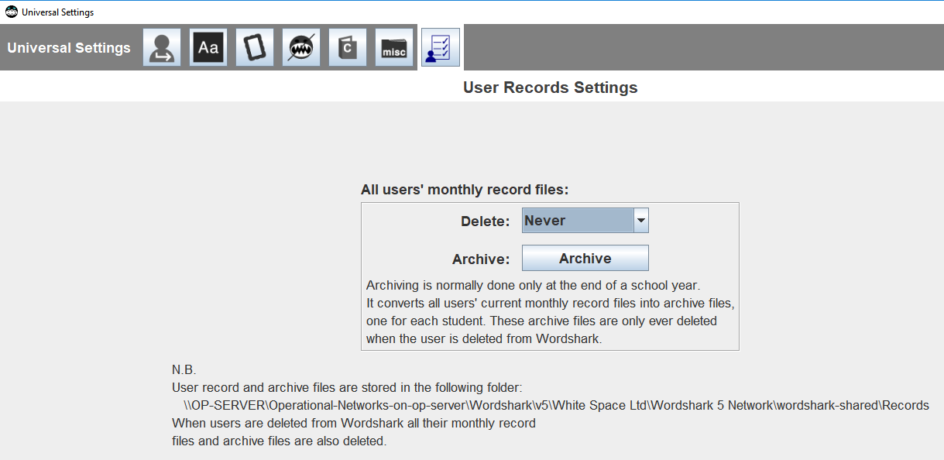Note in your diary to “spring clean” the program annually: Sign on as program admin, go to “Universal Settings” and the final icon. Delete and archive record files if these are likely to be no longer required. Retention of more than 5 years is rarely required!
* 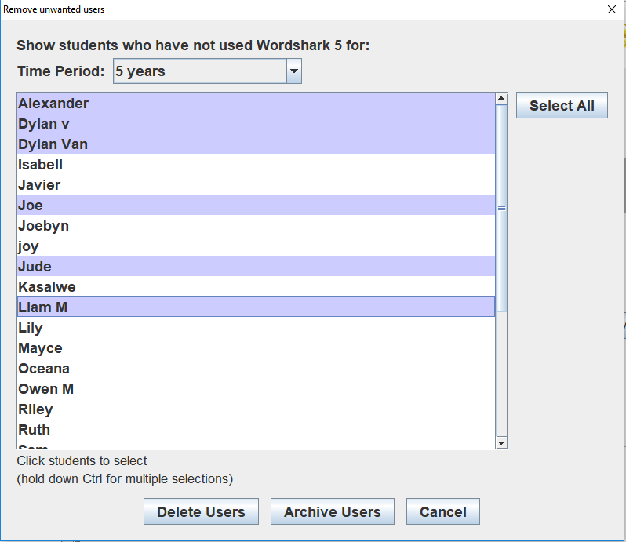Further “spring cleaning” is possible: Go to the “Admin” menu again, this time to “Add and Manage”. Note the “Redundant Students” icon, left hand column. Again, choose an appropriate time period to delete users.
* It is worth being aware that Wordshark users may create their own “Word lists”, which are stored in the wordshark-shared folder: These can consist of a text word, one or two sound files and a picture for up to around 10 words. A word list with 10 words and all of these components will use around 2Mb. A very industrious teacher might create many word lists. 500 such word lists would equate to around 1Gb of word lists, though such industrious staff are exceptionally rare! It is possible to “export” word lists via the user’s Actions / Own word lists / Export icon, if useful word lists need to be retained for future use but are not needed for the current year. They can then be imported via the user’s Actions / Own word lists / Import icon.
* Staff may “back up” user data. This is stored in the [word][number]shark-shared/WSBackups or NSBackups folders. This is rarely done – but if a member of staff starts doing this you can find the [word][number]shark-shared can grow in an unexpectedly quick fashion. If you are already backing up the user folders, it may be worth mentioning to staff that they should not need to do so!

Navigate to: Contents Instructions Stage 1 Stage 2 Stage 3 Stage 4 Trouble-shooting Contact

# Appendix Q: How to check that .Net is present

The server running our Service and Manager requires .Net Framework to be present:

* Our older Service and Manager v1.0.8.0 requires .Net 3.5.2
* Our current Service and Manager v2.0 requires .Net 4.7.2 or later.

The two programs, along with the original self-extracting zip files, the extracted zip files, the program files, service, manager, and also include allowing for build-up of 1000 or so user files/ records / diagnostic logs for 2-3 years, can require around 8Gb of disk space (around 4.5 Gb for Wordshark and 3.5Gb for Numbershark).

This article may be useful: [https://docs.microsoft.com/en-us/dotnet/framework/migration-guide/how-to-determine-which-versions-are-installed](https://eur03.safelinks.protection.outlook.com/?url=https%3A%2F%2Fdocs.microsoft.com%2Fen-us%2Fdotnet%2Fframework%2Fmigration-guide%2Fhow-to-determine-which-versions-are-installed&data=02%7C01%7CVincent.Chiloane%40itmaster.co.za%7Cc5c8f0126a8f4ce32a4f08d850ba19c2%7Ce33296ff36f9495e940545f11f6b3caa%7C1%7C0%7C637348107583491843&sdata=XCEfBQHWgO7nK4XPZDhNnwd%2BNv7Rc3S4Ai74G1ZCz1k%3D&reserved=0)

Briefly, to run our Service and Manager v2 first check that the machine’s registry contains .Net 4.7.2 or later

The following screenshot show where to look:

Computer\HKEY_LOCAL_MACHINE\SOFTWARE|Microsoft|NET fram check for this. In this case, the Version shown is 4.803752:

